PHYLOGENETIC RELATIONSHIPS AND TAXONOMY OF SOME SPECIES OF AMARANTHACEAE BASED ON MORPHOLOGICAL TRAITS AND ANTIMICROBIAL EFFECTS AGAINST SOME ISOLATED PATHOGENIC BACTERIA

AHMED El-SHABASY¹ and KHALED E. El-GAYAR^{1,2}
¹ Department of Biology, Faculty of Science, Jazan University, Kingdom of Saudi Arabia.
² The Holding Company for Biological Products & Vaccines (VACSERA), Egypt.
Corresponding Author's e.mail: k_elgayar@yahoo.com

Abstract
The present study illustrated the phylogenetic relationships and taxonomy among some species of Amaranthaceae using morphological traits besides antimicrobial effects of their solvent extracts. Amaranthus hybridus and Amaranthus viridis were recorded as closely species while Aerva javanica and Amaranthus viridis were distantly related species. Plant extracts were done using chloroform. Two pathogenic bacteria were identified as Klebsiella pneumoniae and Staphylococcus pasteuri. Using the disk diffusion assay, Staphylococcus pasteuri and Klebsiella pneumoniae demonstrated a multiple resistance against 37% and 64% of the tested antibiotics respectively. Amaranthaceae species; Aerva javanica, Aerva lanata, Amaranthus graecizans ssp. silvestris, Amaranthus hybridus, Amaranthus viridis and Digera muricata extracts were tested as antimicrobial agents against three pathogenic bacteria (Brevibacterium lines, Staphylococcus pasteuri and Klebsiella pneumonia). The current results showed that the most susceptible organism was Klebsiella pneumoniae which was sensitive to all extracts. The growth of Staphylococcus pasteuri was inhibited at lower dose (1.5mg/well) using Amaranthus viridis and Digera muricata extracts. Meanwhile it had begun inhibition at 3mg/well against the others extracts and reached to the maximum inhibition at 6 mg/well using Amaranthus viridis.The lowest growth of Brevibacterium linens inhibition was at 1.5 mg/well using Amaranthus viridis,Digera muricata, Aerva javanica and Amaranthus hybridus. However the lower inhibition using both of Amaranthus graecizans and Aerva lanata was at extract concentration 3mg/well and gave the highest inhibition with Digera muricata at 6 mg/well. From these results, it was proved that some species of Amaranthaceae have antimicrobial effect against some pathogenic bacteria.
Keywords: Amaranthaceae , Brevibacterium lines, Staphylococcus pasteuri and Klebsiella pneumonia, antimicrobial activity.
Introduction
Nature has provided an important source of remedies to cure all the ailments of mankind (Ravinder, 2011). Scientifically many works have been expended to evaluate and discover new antioxidant, antimicrobial and antifungal ingredients from different kinds of natural sources like soil, microorganisms, animals and plants (Nagesh et al., 2012). Plants are important source of potentially useful structures for the development of new chemotherapeutic agents (Yousuf et al., 2012). A significant number of modern pharmaceuticals drugs are based on or derived from medicinal plants. Thus, The World Health Organization estimates that medicinal plants would be the best source to obtain a variety of drugs (Bisignano et al., 1999). The extract of medicinal plants primarily serves for the treatment of diseases and maintains or improves health (Mitra et al., 2015). Isolated drug from medicinal plant extract has many advantages such as safety, efficacy, cultural acceptability, better compatibility with human body and lesser side effects (Namdeo, 2007). On the other hand, synthetic medicines are high cost and have side effects with lack of access to healthcare (Konat´e et al., 2012). Recently, multiple drug resistance in human or animal pathogenic microorganism has been developed due to indiscriminate use of antimicrobial drugs commonly used in the treatment of such diseases (Manickam & Veerabahu, 2014). In addition to this problem, antibiotics are sometimes associated with adverse effects on the host including hypersensitivity, immune suppression and allergic reactions (Monroe & Polk, 2000). To overcome this growing problem, antibiotic resistance plants are of great interest (Sumitra et al., 2010) and therefore, there is a need to develop alternative antimicrobial drugs for the treatment of infectious diseases from medicinal plants (Samin et al., 2008). Many investigations have demonstrated that the antimicrobial activity of the extracts of medicinal plants has the same effects of antibiotics and gives cheap and benefit treatments for the same microbe (Akinpelu & Onakoya, 2006). The information obtained from ethno- medicine is therefore being put on a scientific basis and it is very important to investigate the pharmacological and phytochemical aspects of different preparations from plant sources (Hostettman & Marston, 1996). Many researchers reported ethno-pharmacological and nutritional importance's of plant species belonging to Amaranthaceae in their works (Mitra et al., 2015).They are used in the treatment of intestinal bleeding, diarrhea and excessive menstruation (He et al., 2003). In the last decade, the use of Amaranth sp. has expanded not only in the common diet, but also in diet of people with celiac disease or allergies to typical cereals (Berti et al., 2005).
Staphylococcus is a genus of Gram-positive bacteria, round (Cocci), and form in grape-like clusters (Madigan & Martinko, 2005). Staphylococci are commonly found on the skin of mammals and birds, and on environmental surfaces and humans are thought to be a primary source of food matrix staphylococcal toxicity (Hong et al., 2014). Staphylococcus pasteuri is a coagulase-negative, Gram positive organism which is emerging as an agent of the most common cause of nosocomial bloodstream infections, especially in patients with intravascular catheters (Carretto et al., 2005; Savini et al., 2009).Because of the diversity of bacteria constituting the skin flora, the repeated presence of the same organism in consecutive blood cultures may indicate the clinical significance of coagulase-negative Staphylococcus (CoNS) isolates (Carretto et al., 2005). Antibiotic resistant pathogens are one of the most serious problems in many countries and can be a source of food contamination (Hong et al., 2014). Despite the paucity of isolates recovered, this bacterium has recently appeared to express resistance against several classes of antibiotic compounds, such as methicillin/oxacillin, macrolides, lincosamides, streptogramins, tetracyclines, chloramphenicol, streptomycin, fosfomycin, as well as quaternary ammonium compounds (Savini et al., 2009). Klebsiella spp. is among the most common pathogens isolated in intensive care units (ICUs) (Sanchez et al., 2013). Klebsiella pneumoniae is one of these multidrug resistant organisms identified as an urgent threat to human health by the World Health Organization, the US Centers for Disease Control and Prevention and the UK Department of Health. K. pneumoniae infections are a problem among neonates, elderly and immunocompromised individuals within the healthcare setting, but this organism is also responsible for a significant number of community‐acquired infections including pneumonia and sepsis (Paczosa & Mecsas, 2016; Quan et al, 2016; Kidd et al., 2017). Brevibacterium is a genus of Gram-positive soil organisms. It is the sole genus in the Brevibacteriaceae (Bernard et al., 2010). Brevibacterium linens is present on the human skin, where it causes foot odor. This smell is due to sulphur containing compounds known as S-methyl thioesters (Bernard, 1996).
Therefore, the present study was carried out to evaluate the effect of antibacterial activity of definite number of plant species extracts belonging to Amaranthaceae family; Aerva javanica (Burm. f.) Juss. ex Schult, Aerva lanata (L.) A. L. Juss. ex Schultes, Amaranthus graecizans ssp. silvestris, Amaranthus hybridus L., Amaranthus viridis L. and Digera muricata (L.) Mart collecting from Jazan region in Kingdom of Saudia Arabia on some microbial pathogens; Staphylococcus pasteuri , Klebsiella pneumonia and Brevibacterium linens with comparing the results to the effect of some antibiotics upon bacterial growth besides determine the phytorelationship between members of Amaranthaceae family on traditional and modern basis.
Materials and Methods
Collection of plant material and preparation
Freshly whole plant samples of Amaranthaceae species; Aerva javanica, Aerva lanata, Amaranthus graecizans ssp. silvestris, Amaranthus hybridus,Amaranthus viridis and Digera muricata (photo 1-6 respectively) were collected from Jazan region, Kingdom of Saudi Arabia during March 2017. They were identified by the herbarium of the Biology Department, Faculty of Science, Jazan University. They were washed thoroughly 2-3 times with running tap water and then once with sterile water, dried, subsequently ground into fine powder. The powder was used for extraction of crude extracts with organic solvents.
Extraction of the plant material
Plant powder (20g) was mixed with 200mL of each solvent system (ethanol, methanol and chlorogorm) in conical flasks. Extraction was carried out in an orbital shaker for 6 hours at room temperature (Sultana et al., 2009), filtered and residue was extracted twice. The combined supernatants were dried in a rotary evaporator and stored in cool dry place till further analysis.
Bacterial strains and growth media
In this study, three bacterial strains were used for antibacterial activities test. In a previous study Brevibacterium linens isolated from hot springs water have been tested for their sensitivity to antibiotics (Elgayar et al., 2017). Two bacterial strains were isolated from domestic waste water and tested against both of antibiotics and plants extracts. All strains were isolated from Jazan province, KSA. Macconkey agar used in isolation of Enterobacteriaceae bacteria and Manitol salt agar was used for isolation of Staphylococcus bacteria. Nutrient agar medium was used for all antimicrobial tests.
Morphological and biochemical tests
After isolation on Macconkey agar and Manitol salt, the isolates were tested by Gram staining and observed under a high power magnifying lens in light microscope. Biochemical identification of the bacterial isolates was done according to (Selim et al,. 2017) using miniaturized multitests identification systems API (BioMérieux, France). Regarding to the manual instructions provided by the manufacturer where API 20E was used for identification of members of the family Enterobacteriaceae. APIWEB software was used for identification and considered acceptable when given a probability of 85% or greater. The 2nd bacterial isolate was identified using GEN III MicroPlate™ test panel of the Biolog System (Biolog, Inc., Hayward, USA). The results interpreted by the identification systems software (GEN III database, version 5.2.1).
Antibacterial activities:
The antibacterial activity and minimum inhibitory concentrations (MICs) were evaluated by using agar well diffusion method (Singh, 2011). 100µl of an O/N broth bacterial culture containing was smeared on the surface of Nutrient agar plates. Wells were dug in the agar with the help of sterile cork borer. 3, 6, 9 and 12 mg stock solution containing test extracts (1-6) were added in the respective wells. Controls containing absolute solvent and sterile distilled water and no extracts of tested plants were tested. All plates were incubated for 48h at 37◦C (Khan, et al., 2014).
Antibiotics susceptibility test was performed using disc diffusion method (Mulamattathil et al., 2014; Elgayar, 2017). A single bacterial colony was picked using a sterile loop and streaked on the nutrient agar plate. A filter paper disk saturated with the following antibiotics (Mast Diagnostics, Bootle, UK); amikacin (30μg), gentamicin (10μg), cefepime (30μg), ticarcillin (75μg), piperacillin (100μg), imipenem (10μg), colistin (10μg), riampicin (5μg), penicillin G (10 units μg), erythromycin (15μg), cephalothin (30μg), clindamycin (2μg), cotrimoxazole (25μg) and ampicillin (10μg) were dispensed onto the media plate separately. Using a sterilized forceps, each disc was placed on the nutrient agar medium to ensure that the disc are attached and fixed on the agar. Nutrient agar medium containing antibiotic discs were incubated overnight at 35 °C
Phylogenetic data and cluster analysis
The morphological characters and antimicrobial effects are scored to form phenetic analysis to the studied species of Amaranthaceae. Similarity matrix and cluster analysis were constructed by using Pclass (Dallwitz et al. 2000; El-Gazzar & Rabei 2008), where distances were calculated using a modification of the Gower coefficient (Gower 1971; 1982). Sequential agglomerative, hierarchic nest clustering was done with UPGMA (Sneath & Sokal 1973).

Results
Identification of the bacterial isolates
The bacterial isolate (S1) was Gram-negative rod-shaped cells. While the bacterial isolate (S2) was Gram – positive round shaped cells grape-like clusters. According to the metabolic fingerprints as mentioned in materials and methods and showed in (Tables 1 and 2), the isolate S1 was identified as Klebsiella pneumoniae meanwhile the S2 isolate was identified as Staphylococcus pasteuri.
Antibiotics susceptibility test
Determination of Antibiotics susceptibility was using the disk diffusion assay. The obtained results (Table 3 and Figure 1) showed the antibiotic susceptibility pattern of the both bacterial isolates. The inhibition zone represents the zone diameter in which no bacterial growth was noticed. The both bacterial isolates were sensitive against the same antibiotics with different degrees; Imipenem , Amikacin , Piperacillin and Gentamicin. Staphylococcus pasteuri was sensitive against Ticarcillin, Cotrimoxazole, Cefepime, Clindamycin and Riampicin. Staphylococcus pasteuri and Klebsiella pneumoniae demonstrated a multiple resistance against 37% and 64% of the tested antibiotics respectively. The both bacterial isolates were resistant against the same antibiotics; Ampicillin, Erythromycin, PenicillinG, Colistin and Cephalothin. But also Klebsiella pneumoniae was resistant to Ticarcillin, Cefepime, Clindamycin and Riampicin. At the same time; previous isolated, identified and antibiotics resistance tested; Brevibacterium lines strain were used as control. It was multiple resistances against 43% of the tested antibiotics.
Amaranthaceae extracts antibacterial effect
The preliminary experiment showed that the chloroform extract was the most inhibitor than methanol, ethanol and water extracts against pathogenic bacteria. The result in table (4) and Figure (2) showed the effects of chloroform extracts of some Amaranthaceae species; Aerva javanica, Aerva lanata, Amaranthus graecizans ssp. silvestris, Amaranthus hybridus, Amaranthus viridis and Digera muricata against three pathogenic bacteria (Brevibacterium lines, Staphylococcus pasteuri and Klebsiella pneumonia). The inhibition zone refers to the diameter of clear zone (no bacterial growth) subtract the diameter of the agar well (5 mm). All tested extracts had showed antibacterial activities against the chosen pathogens with different degrees. The minimum inhibitory concentration (MIC) Values for extracts against the bacterial strains varied from extract to the other. The current results showed that the most susceptible organism was Klebsiella pneumoniae which was sensitive to all extracts with MIC 1.5mg/well and reached to the maximum at 6 mg/well with diameters ranged from 20 to 35 mm, except in case of Digera muricata was 10mm. The growth of Staphylococcus pasteuri was inhibited at lower dose (1.5mg/well) against Amaranthus viridis and Digera muricata extracts. Meanwhile it had begun inhibition at 3mg/well against the others extracts and reached to the maximum inhibition at 6 mg/well with diameter 25 mm against Amaranthus viridis.The lowest growth of Brevibacterium linens inhibition was at 1.5 mg/well against Amaranthus viridis,Digera muricata, Aerva javanica and Amaranthus hybridus. However the lower inhibition against both of Amaranthus graecizans and Aerva lanata was at extract concentration 3mg/well and gave the highest inhibition with Digera muricata (20mm) at 6 mg/well.
Cluster analysis as revealed by morphological characters and antimicrobial effects.
The morphological characters of studied plant species besides their antimicrobial effects were presented as (+) for present, (-) for absent (Table 5) & (Table 6). The binary matrix was analyzed using ‘SIMQUAL’ sub-program and NTSYS-pc version 2.11w software (Rohlf, 1993) to calculate the similarity values and generate the phenogram. The Nei genetic similarity index (SI) was utilized for estimating the pairwise similarity between the operational taxonomic units (OTUs) on the basis of the equation, SI = 2Nij / (Ni + Nj), where Nij is the number of common characters shared between species i and j, Ni and Nj are the total number of characters for species i and j, respectively (Nei, 1978) (Table 7). After obtaining the similarity matrix, clustering was performed by a distance based method of sequential agglomerative hiearchical nested clustering where series of successive mergers are used to group species with similar characteristics (Sneath & Sokal, 1973). The graphical representation of the cluster (phenogram) was obtained by using ‘SAHN’ sub-program of NTSYS-PC software; the unweighted pair group method of mathematical averages (UPGMA) (Yao et al., 2007) (Figure3).
Discussion
Multidrug resistant bacteria are one of the most important current threats to public health. Typically, these bacteria are associated with nosocomial infections. However, some of them have become quite prevalent causes of community-acquired infections (Zunita et al., 2008; Orsi et al., 2011; Van Duin & Paterson 2016;). There are several types of multidrug resistant bacteria that may be found in healthcare facilities, including carbapenem-resistant Enterobacteriaceae (CRE), methicillin-resistant Staphylococcus aureus (MRSA), vancomycin resistant Staphylococcus aureus(VISA/VRSA), and vancomycin-resistant Enterococci (VRE) (Da Silva et al., 2011). Staphylococcus silently stays as our natural flora, and yet sometimes threatens our life as a tenacious pathogen. In addition to its ability to outwit our immune system, its multi-drug resistance phenotype makes it one of the most intractable pathogenic bacteria in the history of antibiotic chemotherapy (Hiramatsu et al., 2014). Carbapenems resistance in Klebsiella pneumoniae strains, results from the presence of plasmid-encoded K. pneumoniae carbapenemase, is one of the leading causes of hospital-acquired infections, characterized by high rate of morbidity and mortality (Cella et al., 2017).
Natural products are considered traditionally as the rich source of phytochemicals with bioactivities against a number of diseases including infectious diseases. More than 80 % of the total world’s population relies on herbal medicine to meet their primary health care needs (Salvador et al., 2003; Abdulla Al-Mamun et al., 2016). So Majority of individuals in developing nations depend on plants for medicine (Da Silva et al., 2011; Okpako & Ajibesin, 2015) . The importance of the medicinal plants is that it is an important source of active molecule isolation and these molecules can be used as model for the chemical synthesis of new prototypes and for this reason they consist in rich environment for the scientific research (Da Silva et al., 2011). A wide variety of secondary metabolites, which are used either directly as precursors or as compounds in the pharmaceutical industry are produced by plants. It is expected that other than plant used by antibiotics, plant extracts showing target sites will be more active against drug-resistant microbial pathogens. The antimicrobial potency of plants is believed to be due to tannins, sponins, phenolic compounds, essential oil, and flavonoids (Saeidi et al., 2015).
Several species of Amaranthus have been reported to contain various bioactive phytochemicals such as carotenoids, ascorbic acid, flavonoids and phenolic acids. Amaranthus has well been documented to possess important pharmacological properties including anticancer , anti-inflammatory and antioxidant activity(Abdulla Al-Mamun et al., 2016). The isolation and identification of the active compounds present in these extracts and their action mechanisms are the biggest challenge for the chemical chemistry, biochemistry and pharmacology (Da Silva et al., 2011).
In previous study was carried out to evaluate the antibacterial activities of methanolic extract and various fractions of A. javanica. The fractions of A. javanica were evaluated against six bacterial strain, Escherichia coli, Bacillus subtilis, Pseudomonas aeruginosa, Staphylococcus aureus, Shigella flexenari and Salmonella typhi. Some of the solvent extracts of the plant showed significant activity against some bacteria as compared to standard drug used (Khan et al., 2014). Also A. viridis leaves and stem extracts in different solvents chloroform, ethanol and methanol were investigated for their antibacterial potentiality against Gram-positive (Staphylococcus aureus) and Gram -negative (E.coli and K.pneumoniae) bacteria. Comparative analysis by ANOVA exhibited that a significant variation exists between the antimicrobial activities of stem and leaves extracts of all solvents (Malik et al., 2016).In another study the successive Soxhlet extract of Digera muricata (L.) Mart. (Amaranthaceae) were extracted using petroleum ether, chloroform, ethanol and distilled water in ascending order of the polarity. These extracts subjected to the antimicrobial activity. Among the bacteria used, the petroleum ether extract gave highest zone of inhibition against V. cholera (Mathad & Mety, 2010). Methanol extracts of the dried leaves and seeds of Amaranthus viridis were collected and used for phytochemicals and antibacterial analysis. By detecting the MIC and zone inhibition, the antibacterial activity was determined against different bacterial and fungal strains. The MIC of extracts against Staphylococcus aureus and Escherichia coli, together with two pathogenic fungi; Fussarium solani and Rhizopus oligosporus ranged 178 - 645 μg/mL (Ahmed et al., 2013). An in vitro antimicrobial activity of various extracts of Celosia argentea viz. petroleum ether, chloroform, acetone, ethanol and aqueous extracts were showed high antimicrobial activity against fungi; Candida albicans and bacteria; E.coli, Staphylococcus aurus, Klebsiella pneumonia and Salmonella typhi (Thakur, 2016).
The output of SAHN-clustering program was presented in the form of a phenogram by using the tree display graphic (TREE). The resulting phenogram, Figure (3), showed that the studied species have an average taxonomic distance of about 0.89. At this level the species are differentiated into two main groups. The first group includes Aerva javanica , Aerva lanata and Digera muricata. Aerva species are delimited as a subgroup at 1.132 level where Digera muricata is split at 1.00 level. The second group includes other Amaranthus species at 1.26 level. Amaranthus hybridus and Amaranthus viridis are sub grouped at 1.32 level.
Based on the above results, high similarity indices suggest that the species have close genetic relationship among them (Sayed et al., 2009). Table 7 shows similarity indices between the six species where the high value indicated a close relationship between the two species and the low value indicated remote relationships between the two species. The highest similarity value (0.88) was recorded between Amaranthus hybridus and Amaranthus viridis indicating that these two species were closely related to each other. On the other hand, the lowest similarity value (0.53) was recorded between Aerva javanica and Amaranthus viridis indicating that these were distantly related species.
Conclusion
- Amaranthaceae species have antimicrobial effect against some pathogenic bacteria.
- The modern trends of plant taxonomy (ex. antimicrobial effects) can support the classic ones (ex. morphological traits) in differentiation between members of the same family.
Acknowledgment
The authors gratefully acknowledge all the staff of the Biology Department, Faculty of Science, Jazan University, KSA especially Herbarium Staff and Dr. Ashraf E. Essa, Associate prof. of Microbiology.
References
Abdulla Al-Mamun, M., J. Husna, M. Khatun, R. Hasan, M. Kamruzzaman, K. M. F.Hoque, M. Abu Reza. and Z. Ferdousi.2016. Assessment of antioxidant, anticancer and antimicrobial activity of two vegetable species of Amaranthus in Bangladesh. BMC Complementary and Alternative Medicine, 16:157.
Ahmed, S. A., S. Hanif and T. Iftkhar. 2013. Phytochemical Profiling with Antioxidant and Antimicrobial Screening of Amaranthus viridis L. Leaf and Seed Extracts. Open Journal of Medical Microbiology, 3:164-171.
Akinpelu, D. A. and T. M. Onakoya. 2006. Antimicrobial activities of medicinal plants used in folklore remedies in south-western Africa. Afr. J. Trad. CAM, 3: 112-115.
Bernard, K. A., D. Wiebe, T. Burdz, A. Reimer, B. Ng., C. Singh, S. Schindle and A. L. Pacheco. 2010. Assignment of Brevibacterium stationis (ZoBell and Upham 1944) Breed 1953 to the genus Corynebacterium, as Corynebacterium stationis comb. nov., and emended description of the genus Corynebacterium to include isolates that can alkalinize citrate. International Journal of Systematic and Evolutionary Biology, 60:874–879.
Bernard, D. 1996. Cheese, toes, and mosquitoes. British Medical Journal, 312 (7038): 1105.
Berti, C., P. Riso, A. Brusamolino and N. Porrini. 2005. Effect on appetite control of minor cereal and pseudocereal products. British. J. Nutr., 94: 850-858.
Bisignano, G., A. Tomaino, R. L. O. Cascio, G. Crisafi, N. Uccella and A. Saija. 1999. On the in-vitro antimicrobial activity of oleuropein and hydroxytyrosol. J Pharm Pharmacol, 51:971-974.
Carretto, E., D. Barbarini, I. Couto, D. De Vitis, P. Marone, J. Verhoef, H. De Lencastre and S. Brisse. 2005. Identification of coagulase-negative staphylococci other than Staphylococcus epidermidis by automated ribotyping. Clin Microbiol Infect, 11: 177–184.
Cella, E., M. Ciccozzi, A. Lo Presti, M. Fogolari, T. Azarian, M. Prosperi, M. Salemi, M. Equestre, F. Antonelli, A. Conti, M. De Cesaris, S. Spoto, R. A. Incalzi, R. Coppola, G. Dicuonzo and S. Angeletti. 2017. Multi-drug resistant Klebsiella pneumoniae strains circulating in hospital setting: whole genome sequencing and Bayesian phylogenetic analysis for outbreak investigations. Scientific reports.
Dallwitz, M. J., T. A. Paine and E. J. Zurcher. 2000. User’s guide to the DELTA system: A general system for processing taxonomic descriptions. 4.12 ed. CSIRO Division of Entomology, Canberra, ACT, Australia.
Da Silva, L. C., K. A. Pegoraro and A. V. Pereira. 2011. Antimicrobial Activity of Alternanthera brasiliana Kuntze (Amaranthaceae): a Biomonitored Study. Latin American Journal of Pharmacy, 30 (1): 147-53
El-Gayar, K., E. 2017. Isolation, identification and characterization of Bacillus subtilis from tap water. Asian Jr. of Microbiol. Biotech. Env. Sc, 19 (4):39-52.In press
El-Gayar, K. E., M. A. Al Abboud and A. M. M. Essa. 2017. Characterization of Thermophilic Bacteria Isolated from two Hot Springs in Saudi Arabia. Journal of pure and applied microbiology, 11(2): 743-752.
El-Gazzar, A. and S. Rabei. 2008. Taxonomic assessment of five numerical methods and its implications on the classification of Hyptis s. l. (Labiatae). Int. J. Bot., 4: 85–92.
Gower, J.C. 1971. A general coefficient of similarity and some of its properties. Biometrics, 23: 623–637.
Gower, J.C. 1982. Euclidean distance geometry. Math. Sci., 7: 1–14.
Hong, J., L. Quan, S. Heu, K. S. Jung, S. Han, E. Moon and E. Roh. 2014. A New Antimicrobial Substance Produced by Staphylococcus pasteuri isolated from vegetables. Food Sci. Biotechnol., 23(3): 983-990.
Hostettman, K. A. and A. Marston. 1996. Saponin chemistry and pharmacology of natural products. Cambridge University press Cambridge U. K. pp 11.
He, H. P., H. Corke and J.G. Cai. 2003. Supercritical carbon dioxide extraction of oil and squalene from Amaranthus grain. J. Agric. Food Chem., 51: 7921-7925.

Hiramatsu, K., Y. Katayama, M. Matsuo, T. Sasaki , Y. Morimoto, A. Sekiguchi and T. Baba.2014. Multi-drug-resistant Staphylococcus aureus and future chemotherapy. J Infect Chemother.,20 (10):593-601.
Khan, A., S. Jan, F. U. Khan, N. Muhamamd and R. A. Khan. 2014. Antibacterial Activity of Crude Extracts of Aerva javanica. World Applied Sciences Journal, 29 (4): 486-488.
Kidd, T J., G. Mills, J. Sá-Pessoa, A. Dumigan, C. G. Frank, J. L. Insua, R. Ingram, L. Hobley and J. A. Bengoechea.2017. A Klebsiella pneumoniae antibiotic resistance mechanism that subdues host defenses and promotes virulence. EMBO Mol Med., 9(4):430-447.
Konat´e, K., A. Hilou and J. F. Mavoungou. 2012. Antimicrobial activity of polyphenol-rich fractions from Sida alba L. (Malvaceae) against co-trimoxazol-resistant bacteria strains, Annals of Clinical Microbiology and Antimicrobials, 11(5).
Madigan, M., J. Martinko, eds. 2005. Brock Biology of Microorganisms (11th ed.). Prentice Hall.
Manickam, M. and R. M. Veerabahu. 2014. Phytochemical, FT-IR and antibacterial activity of whole plant extract of Aerva lanata (L.) Juss. Ex. Schult. Journal of Medicinal Plants Studies. 2(3):51-57.
Mathad, P. and S. S. Mety. 2010. Phytochemical and Antimicrobial Activity of Digera Muricata (L.) Mart. E-Journal of Chemistry. 7(1):275-280.
Mitra, N., M Talebi and Z. Nasiri. 2015. Seven Amaranthus L. (Amaranthaceae) Taxa Flavonoid Compounds from Tehran Province. Iran International Journal of Modern Botany, 5(1): 9-17.
Malik, K., F. Nawaz and N. Nisar. 2016. Antibacterial Activity of Amaranthus Viridis. Bull. Env. Pharmacol. Life Sci., 5 (4):76-80.
Monroe, S. and R. Polk. 2000. Antimicrobial use and bacterial resistance. Curr Opin Microbiol.,3:496-.
Mulamattathi, S. G., C. Bezuidenhout, M. Mbewe and C. N. Ateba. 2014. Isolation of Environmental Bacteria from Surface and Drinking Water in Mafikeng, South Africa, and Characterization Using Their Antibiotic Resistance Profiles. Journal of Pathogens.
Nagesh, L., S. Sivasamy, K. Muralikrishna, S. Kishore and G. Bhat. 2012. Antibacterial potential of cell extracts of Quercus infectoria against Enterococcus faecalis an in vitro study. Journal of Pharmacognosy, 4.
Namdeo, A. 2007. Plant cell elicitation for production of secondary metabolites: A review. Pharmacog. Rev., 1: 69-79.
Nei, M.1978. Estimation of average heterozygosity and genetic distance from a small number of individuals. Genetics, 89: 583-590.
Okpako, E. and K. K. Ajibesin. 2015. Antimicrobial Activity of Celosia argentea L. Amaranthaceae. American Journal of Research Communication. 3(5):123-133.

Orsi G. B., M. Falcone and M. Venditti. 2011. Surveillance and Management of Multidrug-resistant Microorganisms. Expert Rev Anti Infect Ther., 9(8):653-679.
Paczosa, M. K. and J. Mecsas . 2016. Klebsiella pneumoniae: going on the offense with a strong defense. Microbiol Mol Biol Rev., 80: 629 – 661.
Quan, T.P., N.J. Fawcett, J.M. Wrightson, J. Finney, D. Wyllie, K. Jeffery, N. Jones, B. Shine, L. Clarke, D. Crook and et al.2016. Increasing burden of community-acquired pneumonia leading to hospitalisation, 1998–2014. Thorax, 71: 535 – 542.
Ravinder, S. 2011. Antimicrobial effect of Callus and Natural plant extracts of Premna serratifolia L. International Journal on Pharmaceutical and Biomedical Research (IJPBR). 2(1):17-20.
Rohlf, F. J.1993. NTSYS-PC – Numerical Taxonomy and Multivariate Analysis. Appl. Biostat., New York, USA. pp. 15.
Saeidi, S., N. A. Boroujeni, H. Ahmadi and M. Hassanshahian. 2015. Antibacterial Activity of Some Plant Extracts Against Extended- Spectrum Beta-Lactamase Producing Escherichia coli Isolates. Jundishapur J Microbiol. 8(2): 15434.
Samin, J., A. K. Mir, D. Siraj, M. Waheed, H. Manzoor and G. Aneela. 2008. Herbal remedies used for gastrointestinal disorders in Kaghan valley, NWFP, Pakistan. Pak J Weed Sci Res, 14:169-200.
Sanchez, G. V., R. N. Master, R. B. Clark, M. Fyyaz, P. Duvvuri, G. Ekta and J. Bordon.2013. Klebsiella pneumoniae Antimicrobial Drug Resistance, United States, 1998–2010. Eid journal.,19(1)
Savini, V., C. Catavitello, A. Bianco , A. Balbinot and D. D'Antonio.2009. Epidemiology, pathogenicity and emerging resistances in Staphylococcus pasteuri: from mammals and lampreys, to man. Recent Pat Antiinfect Drug Discov, 4(2):123-9.
Sayed, M., Z. Hasan, M. Shafie and B. Shafie. 2009. Analysis of random amplified polymorphic DNA (RAPD) of Artemisia capillaries (Worm wood capillary) in east coast of Penisular Malaysia. J. World Appl. Sci ., 6: 976-986.
Selim, H. M. M., N. M. Gomaa and A. M. Essa. 2017.Application of endophytic bacteria for the biocontrol of Rhizoctonia solani (Cantharellales: Ceratobasidiaceae) damping-off disease in cotton seedlings. Biocontrol Science and Technology, 27(1) ·
Salvador, M. J., P. S. Pereira, S. C. França, R. C. Candido, I. Y. Ito and D. A. Dias. 2003. Comparative Study Of Antimicrobial and Antifungal Activity Of Callus Culture and Adult Plants Extracts from Alternanthera maritime (Amaranthaceae). Brazilian Journal of Microbiology, 34:131-136.
Singh, C. R. 2011. Antimicrobial effect of Callus and Natural plant extracts of Premna serratifolia L. International Journal on Pharmaceutical and Biomedical Research (IJPBR),2(1): 17-20.
Sneath, P. H. A. and R. R. Sokal. 1973. Numerical taxonomy – the principles and practice of numerical classification. San Francisco: Freeman: 213.
Sultana, B., F. Anwar and M. Ashraf. 2009. Effect of extraction solvent/technique on the antioxidant activity of selected medicinal plant extracts. Molecules, 14: 2167-2180.
Sumitra, S. D., S. Sh. Sandeep and Kr. Sh. Surendra. 2010. Antibacterial activity of Amaranthus hybridus L. Root Extract. International Journal of Applied Biology and Pharmaceutical Technology, I (1):46-49.
Thakur, H. A.2016. Phytochemical Screening and Antimicrobial Activity of Celosia argentea (Amaranthaceae) An Ethnomedical Plant. International Journal of Recent Scientific Research . 7(10): 13844-13849.
Yousuf, M., K. Aslam, B. A. Wani, N. Asalam, N. A. Dar and I. A. Nawchoo. 2012. In vitro antibacterial activity and phytochemical studies of methanolic extract of leaves of Hypericum perforatum L. growing wild in Kashmir Himalaya. Asian Journal of Plant Science and Research, 2:414-420.
Yao, Q., K. Yang, G. Pan and T. Romg. 2007. Genetic Diversity of Maize (Zea mays L.) Landraces from Southwest China Based on SSR Data. J. Genetic. Genome, 349: 851-860.
Van Duin, D. and D. Paterson .2016. Multidrug Resistant Bacteria in the Community: Trends and Lessons Learned. Infect Dis Clin North Am., 30(2): 377–390.
Zunita, Z., A. Bashir and A. Hafizal. 2008. Occurrence of Multidrug Resistant Staphylococcus aureus in horses in Malaysia. Veterinary World,1(6): 165-167.
List of Tables
Table(1 ). Biochemical characterization of bacterial isolates S1 using API 20NE Tests

Biochemical Test | S1
Ortho nitrophenyl-β-galactosidase | +
Arginine dihydrolase | -
Lysine decarboxylase | +
Ornithine decarboxylase | -
Citrate utilization | +
H₂S production | -
Urease production | +
Tryptophane deaminase | -
Indole production | -
Voges- Proskauer | +
Gelatinase production | -
D-Glucose | +
D-Mannitol | +
Inositol | +
D-Sorbitol | +
L-Rhamnose | +
D-Sucrose | +
D-Melibiose | +
Amygdalin | +
L-Arabinose | +
Oxidase | -
NO₃ | +
N₂ | -
MCB | -
McC | +
OF-O | +
OF-F | +

 | 1 | 2 | 3 | 4 | 5 | 6 | 7 | 8 | 9 | 10 | 11 | 12
A | Negative Control | Dextrin | D-Maltose | D-Trehalose | D-Cellobiose | Gentiobiose | Sucrose | D-Turanose | Stachyose | Positive control | pH 6 | pH 5
A | +/- | +ve | +ve | +ve | +/- | - ve | +ve | +ve | -ve | +ve | +ve | -ve
B | D-Raffinose | α-D-Lactose | D-Melibiose | β-Methyl-D-Glucoside | D-Salicin | N-Acetyl-D-Glucosamine | N-Acetyl-β-D-Mannosamine | N-Acetyl-D-Galactosamine | N-Acetyl Neuraminic Acid | 1% Nacl | 4% Nacl | 8% Nacl
B | +/- | -ve | -ve | -ve | -ve | +/- | +/- | -ve | -ve | +ve | +ve | +ve
C | α-D-Glucose | D-Mannose | D-Fructose | D-Galactose | 3-Methyl Glucose | D-Fucose | L-Fucose | L-Rhamnose | Inosine | 1%sodium lactate | Fusidic acid | D-serine
C | +ve | -ve | +ve | ND | -ve | Ve- | -ve | -ve | +/- | +ve | -ve | -ve
D | D-Sorbitol | D-Mannitol | D-Arabitol | myo-Inositol | Glycerol | D-Glucose- 6-PO4 | D-Fructose- 6-PO4 | D-Aspartic Acid | D-Serine | Troleandomycine | Rifamycine SV | Minocycline
D | +/- | +ve | ND | -ve | +ve | +ve | +ve | -ve | -ve | -ve | -ve | -ve
E | Gelatin | Glycyl-L-Proline | L-Alanine | L-Arginine | L-Aspartic Acid | L-Glutamic Acid | L-Histidine | L-Pyroglutamic Acid | L-Serine | lincomycin | Guanidine HCl | Niaproof4
E | -ve | -ve | -ve | +/- | +/- | +ve | -ve | +/- | +ve | -ve | -ve | -ve
F | Pectin | D-Galacturonic Acid | L-Galactonic Acid Lactone | D-Gluconic Acid | D-Glucuronic Acid | Glucuronamide | Mucic Acid | Quinic Acid | D-Saccharic Acid | Vancomycine | Tetrazolium violet | Tetrazolium blue
F | +ve | -ve | -ve | +ve | -ve | +/- | -ve | -ve | -ve | -ve | +/- | -ve
G | p-Hydroxy- Phenylacetic Acid | Methyl Pyruvate | D-Lactic Acid Methyl Ester | L-Lactic Acid | Citric Acid | α-Keto-Glutaric Acid | D-Malic Acid | L-Malic Acid | Bromo-Succinic Acid | nalidixic acid | Lithium chloride | Potassium tellurite
G | -ve | +ve | +/- | +ve | +ve | -ve | +ve | -ve | -ve | +ve | ND | +ve
H | Tween 40 | γ-Amino-Butryric Acid | α-Hydroxy-Butyric Acid | β-Hydroxy-D,L-Butyric Acid | α-Keto-Butyric Acid | Acetoacetic Acid | Propionic Acid | Acetic Acid | Formic Acid | aztreonam | Sodium butyrate | Sodium bromate
H | -ve | -ve | +/- | -ve | -ve | +/- | -ve | +ve | +/- | +ve | +ve | -ve
Table (2).Physiological profile of bacterial isolate(S2) using Biology system.
N.D: Not determined.

Table (3). The antibiotic sensitivity test of Brevibacterium linens previously identified and the bacterial isolates Klebsiella pneumoniae and Staphylococcus pasteuri .

Klebsiella pneumoniae |  | Staphylococcus pasteuri |  | Brevibacterium linens |  | Antibiotics
Halozone  (mm) | Susceptibility | Halozone  (mm) | Susceptibility | Halozone  (mm) | Susceptibility | Antibiotics
0 | R | 12 | S+ | 0 | R | Ticarcillin (TC)
0 | R | 0 | R | 0 | R | Ampicillin (AP)
0 | R | 0 | R | 20 | S++ | Erythromycin(E)
0 | R | 0 | R | 0 | R | Penicillin G(PG)
0 | R | 17 | S+ | 10 | S+ | Cotrimoxazole(TS)
0 | R | 17 | S+ | 25 | S+++ | Cefepime (CPM)
10 | S+ | 21 | S++ | 24 | S+++ | Amikacin (AK)
0 | R | 14 | S+ | 0 | R | Clindamycin(CD)
18 | S++ | 42 | S+++++ | 35 | S++++ | Imipenem (IMI)
24 | S+++ | 42 | S+++++ | 18 | S++ | Piperacillin (PRL)
0 | R | 0 | R | 0 | R | Colistin(CL)
12 | S+ | 23 | S+++ | 25 | S+++ | Gentamicin(GM)
0 | R | 25 | S++++ | 10 | S+ | Riampicin(RIF)
0 | R | 0 | R | 0 | R | Cephalothin(KF)

Table (4). Antimicrobial effect of some family Amaranthaceae extracts against Brevibacterium linens , Klebsiella pneumoniae and Staphylococcus pasteuri pathogenic bacterial strains

ND, not detected
Staphylococcus pasteuri |  |  |  | Klebsiella pneumoniae |  |  |  | Brevibacterium linens |  |  |  | Tested Bacterial strains
6 | 4.5 | 3 | 1.5 | 6 | 4.5 | 3 | 1.5 | 6 | 4.5 | 3 | 1.5 | Plant extract concentration (mg) | No.
Halozone mm |  |  |  |  |  |  |  |  |  |  |  | Plant extract concentration (mg) | No.
25 | 17 | 15 | 3 | 35 | 30 | 5 | 5 | N.D | 15 | 15 | 10 | Amaranthus viridis | 1
15 | 15 | 4 | 2 | 10 | 10 | 5 | 5 | 20 | 25 | 15 | 10 | Digera muricata | 2
17 | 15 | 4 | 0 | 22 | 15 | 7 | 5 | 5 | 2 | 5 | 0 | Amaranthus graecizans | 3
8 | 5 | 3 | 0 | 35 | 35 | 20 | 5 | 6 | 6 | 5 | 0 | lanata Aerva | 4
20 | 10 | 3 | 0 | 20 | N.D | 15 | 10 | 10 | 10 | 10 | 8 | Aerva javanica | 5
10 | 5 | 2 | 0 | 25 | 20 | 15 | 5 | 9 | 9 | 7 | 5 | Amaranthus hybridus | 6

Table (5) Tabular summary showing the morphological characters for the studied species, where 1: Aerva javanica, 2: Aerva lanata, 3: Amaranthus graecizans, 4: Amaranthus hybridus, 5: Amaranthus viridis and 6: Digera muricata

Morphological characters |  | 1 | 2 | 3 | 4 | 5 | 6
Stem | erect | + | + | + | + | + | +
Stem | glabrous | - | - | + | + | + | +
Stem | terete | + | - | + | + | + | -
Stem | purpule | - | - | + | + | + | -
Leaf | simple | + | + | + | + | + | +
Leaf | alternate | + | + | + | + | + | +
Leaf | petioled | - | - | + | + | + | +
Leaf | obovate | - | + | + | + | + | +
Leaf | entire | + | + | + | + | + | +
Leaf | obtuse | - | + | + | + | + | -
Leaf | glabrous | - | - | + | + | + | +
Leaf | green | - | + | + | + | + | +
Leaf | cuneate base | - | - | - | + | + | -
Spike | unisexual flower | + | - | + | + | + | -
Spike | axillary | - | + | + | - | - | +
Spike | long pedunculate | + | - | - | - | - | +
Spike | white flower | + | + | - | - | - | -
Spike | green flower | - | - | + | - | + | -
Spike | purple flower | - | - | - | + | - | +
Spike | glabrous perianth | - | - | + | + | + | -
Fruit | capsule | + | + | + | + | + | -
Fruit | one seeded | + | - | - | - | - | +

Table (6) Tubular summary showing the antimicrobial effects for the studied species.
1: Aerva javanica, 2: Aerva lanata, 3: Amaranthus graecizans, 4: Amaranthus hybridus, 5: Amaranthus viridis and 6: Digera muricata

Antimicrobial effect |  | 1 | 2 | 3 | 4 | 5 | 6
Brevibacterium linens | 15µl plant extract | + | - | - | + | + | +
Brevibacterium linens | 30 µl plant extract | + | + | + | + | + | +
Brevibacterium linens | 45 µl plant extract | + | + | + | + | + | +
Brevibacterium linens | 60 µl plant extract | + | + | + | + | - | +
Klebsiella pneumoniae | 15 µl plant extract | + | + | + | + | + | +
Klebsiella pneumoniae | 30 µl plant extract | + | + | + | + | + | +
Klebsiella pneumoniae | 45 µl plant extract | - | + | + | + | + | +
Klebsiella pneumoniae | 60 µl plant extract | + | + | + | + | + | +
Staphylococcus pasteuri | 15 µl plant extract | - | - | - | - | + | +
Staphylococcus pasteuri | 30 µl plant extract | + | + | + | + | + | +
Staphylococcus pasteuri | 45 µl plant extract | + | + | + | + | + | +
Staphylococcus pasteuri | 60 µl plant extract | + | + | + | + | + | +

 | Aerva javanica | Aerva lanata | Amaranthus graecizans | Amaranthus hybridus | Amaranthus viridis | Digera muricata
Aerva javanica | 1.00
Aerva  lanata | 0.70 | 1.00
Amaranthus graecizans | 0.56 | 0.74 | 1.00
Amaranthus hybridus | 0.59 | 0.65 | 0.85 | 1.00
Amaranthus viridis | 0.53 | 0.59 | 0.85 | 0.88 | 1.00
Digera muricata | 0.62 | 0.68 | 0.65 | 068 | 0.62 | 1.00
Table (7): Similarity matrix of studied plant species for morphological and antimicrobial analysis.

List of Figures

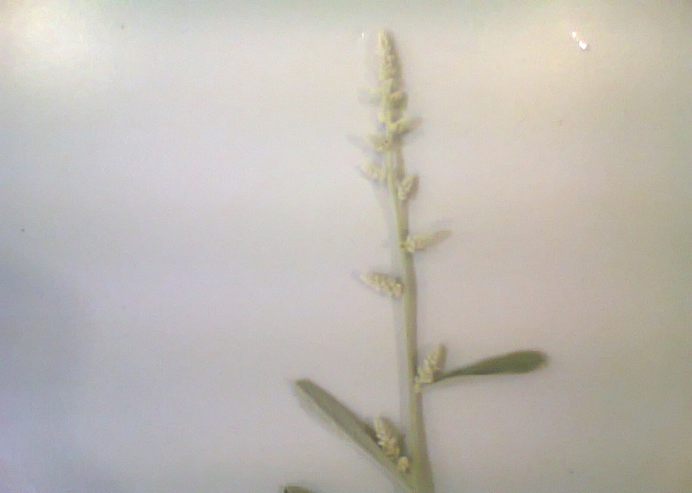

Photo (1): Aerva javanica
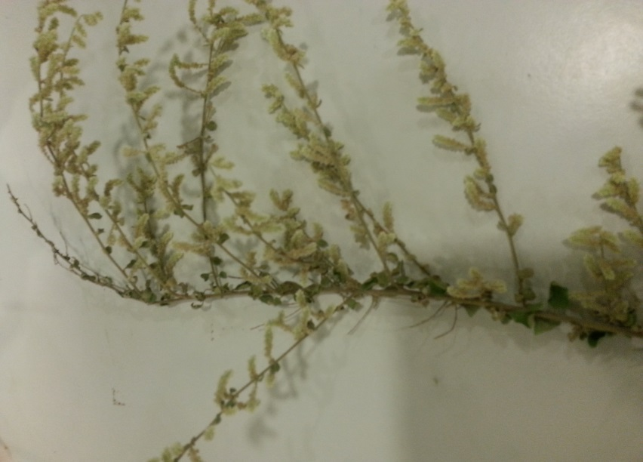

Photo (2): Aerva lanata

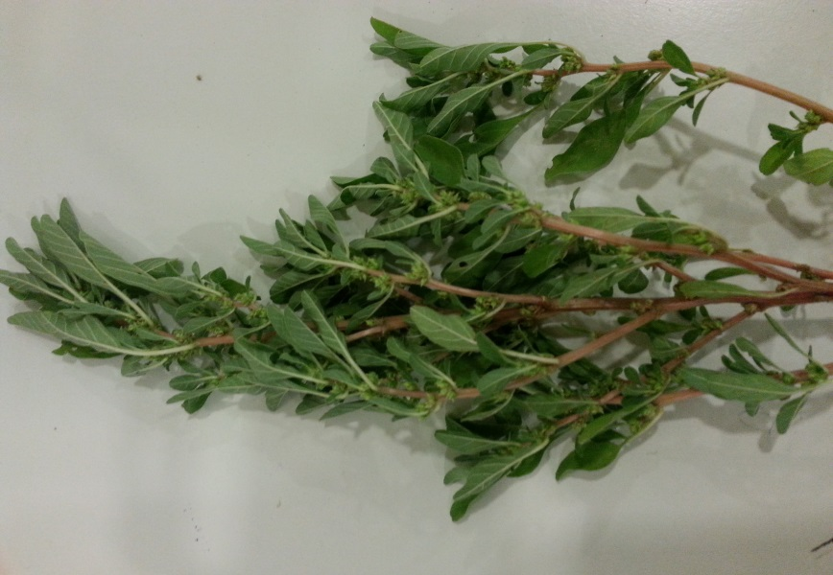

Photo (3): Amaranthus graecizans

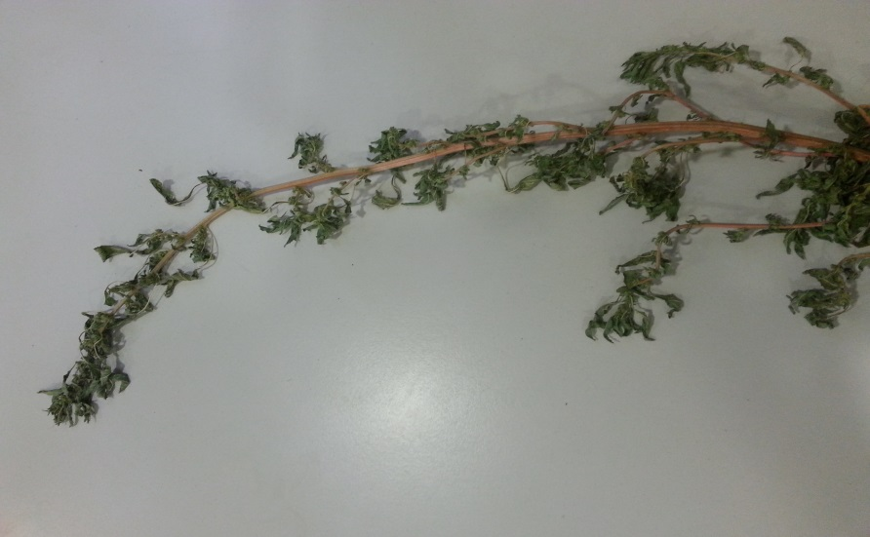

Photo (4): Amaranthus hybridus

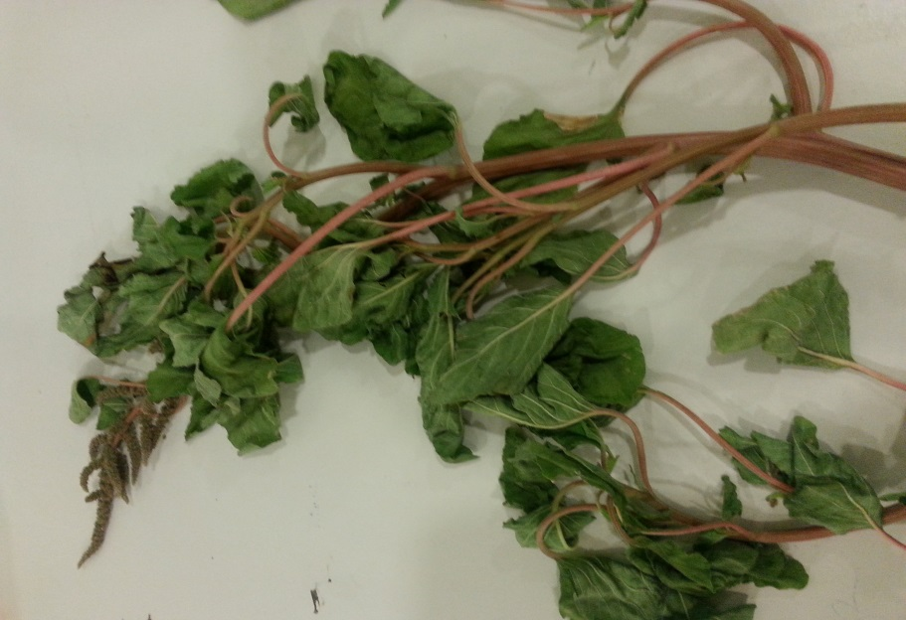

Photo (5): Amaranthus viridis
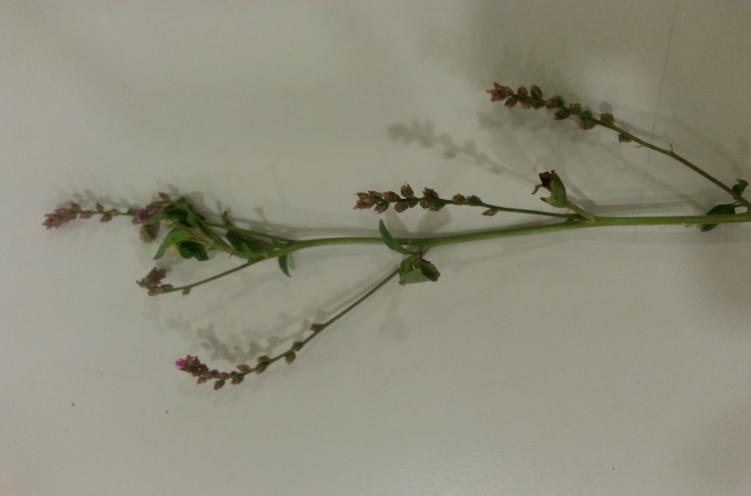

Photo (6): Digera muricata

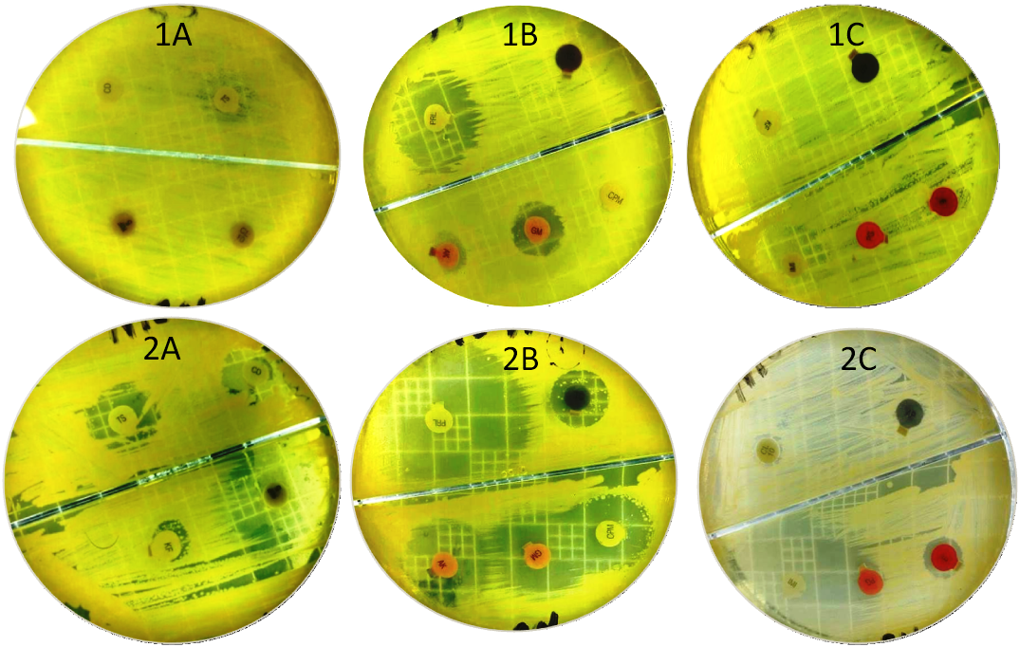

Fig. (1): Effect of some Antibiotics on 1) Klebsiella pneumoniae and 2) Staphylococcus pasteuri as shown in table 3; where A contains Antibiotics CD, TS, KF and RIF. B: contains CPM, GM, AK, PRL and TC. C: contains E, PG, IMI, CL and AP.

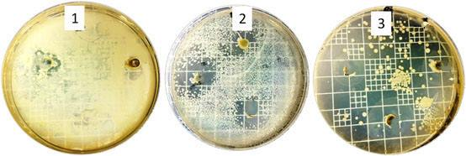Fig. (2): Effect of some chosen concentrations of : a:Amaranthus viridis, b:Digera muricata, c: Amaranthus graecizans,d: Aerva lanata, e: Aerva javanica and f: Amaranthus hybridus on 1) Brevibacterium linens 2)Klebsiella pneumoniae and 3) Staphylococcus pasteuri as shown in table 4
e
e
f

f

a
b
c
d
d

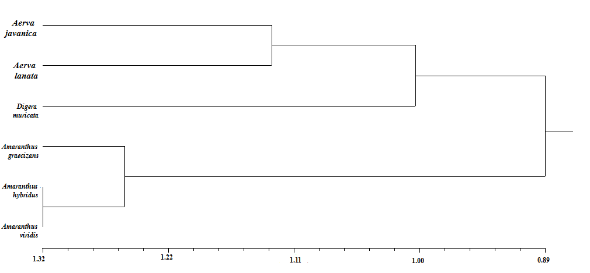

Figure (3): Phenogram of studied species for morphological and antimicrobial analysis.

