Research article
INVESTIGATION OF BIOACTIVE COMPOUNDS AND THEIR BIOLOGICAL ACTIVITIES OF CAESALPINIA BONDUCELLA SEED EXTRACT
Yadala Keerthi Priya ¹, Mohammad Arif ², Gholamreza Abdi ^{3*}, Baber Ali ⁴, Muhammad Hamzah Saleem ⁵, Aqsa Hafeez ⁴, Syed Khalid Mustafa ⁶, Awatif Omran ⁷, Mahmoud Abdelaziz ⁸,Abdulrahman Alasmari ⁹, Azza Alareefy ¹⁰, Shafaqat Ali ^{11, 12}*, Ayman El Sabagh ^{13*}
- Department of Biotechnology, VFSTR (Deemed to be University), Vadlamudi, 522213, Guntur, Andhra Pradesh, India;
- Plant Signalling Group, Max-Planck Institute of Molecular Plant Physiology, 14476 Potsdam-Golm, Germany;
- Department of Biotechnology, Persian Gulf Research Institute, Persian Gulf University, Bushehr, 7516913817, Iran;
- Department of Plant Sciences, Quaid-i-Azam University, Islamabad 45320, Pakistan;
- College of Plant Science and Technology, Huazhong Agricultural University, Wuhan 430070, China;
- Department of Chemistry, Faculty of Science, University of Tabuk, Tabuk 71491, Saudi Arabia;
- Department of Biochemistry, Faculty of science, University of Tabuk, Tabuk, Saudi Arabia;
- Department of Chemistry, Faculty of Science, University of Tabuk, P. O. Box 741, Tabuk 71491, Kingdom of Saudi Arabia;
- Department of Biology, faculty of Science, University of Tabuk, Tabuk Saudi Arabia;
- Jazan university, Clinical Nutrition Department, Applied Medical science collage, Saudi Arabia;
- Department of Environmental Sciences, Government College University, Faisalabad 38000, Pakistan
- Department of Biological Sciences and Technology, China Medical University, Taichung 40402, Taiwan
- Department of Agronomy, Faculty of Agriculture, Kafrelsheikh University, 33156 Kafrelsheikh, Egypt
*Correspondence: ayman.elsabagh@siirt.edu.tr
Abstract
Caesalpinia bonducella belongs to the family Caesalpiniaceae. It has a broad range of pharmacological activities. Therefore, the present work was designed to study the antibacterial, antifungal and antioxidant activities of methanol extracts and compounds from Caesalpinia bonducella seeds. The phytochemical analysis revealed the presence of Phenols, Saponins, Anthroquiones, Lignins, Terpenoids, Triterpenes, Flavonoids, Amino acids, Carbohydrates, Alkaloids, Glycosides, Phytosterols, and Quinones. Further, the functional groups of these phyto-compounds were confirmed by Fourier-transform infrared spectroscopy. The methanol extract was identified with 19 compounds by Gas chromatography-mass spectrometer. Among them, the major 4 compounds have the highest peak area percent. They are Terpenoid-alfa-Copaene (17.9 %), Terpenoid-à-Muurolene (11.6 %), Fatty acid- n-Hexadecanoic acid (5.76 %), poly phenol -2-Propenoic acid, 3-(2-hydroxyphenyl)-, (E) - (4.26%) which are showing biological activity such as antibacterial, antifungal activity antioxidant and anti-inflammatory respectively. The methanol extract was tested against ten bacterial and three fungal strains. Among all the bacteria and fungi tested, the highest MIC was shown by P. aeruginosa with 21.39 mm and A. favus with 28.2 mm. The antioxidant activity of methanol extracts showed LOG IC50-1.330 and IC50 -21.39. Thus, the present study proved that methanol extract has significant potential activity hence it can be used as a functional ingredient in pharmaceuticals drug preparations.
Keywords: Caesalpinia bonducella, Bioactive compounds, GCMS, FTIR, Antimicrobial Activity, Antioxidant activity
1. Introduction
The medicinally important plants are the potential sources to combat threatening diseases in the world. In traditional methods, the usage of plants for medicine still plays an important role in covering the basic human health needs in various countries. Plants are the endless supplies of novel active compounds for the development of new pharmaceuticals. The bioactive compounds of the species can vary depending upon the geographical region, type of soil, level of precipitation, light intensity and humidity [1, 2]. The medicinal values of these traditional plants lie in some biologically active compounds which show a definite physiological effect on the human body. These issues [3] are under active consideration and encourage scientists and researchers to investigate novel active compounds from natural resources.
The earliest forms of medicinal practices are to use traditional plants to treat human ailments [4, 5, 6], which give the knowledge and scientific interest about medicinal plants as an effective alternative to fight against pathogenic microorganisms [7]. An endangered Indian medicinal herb Caesalpinia bonducella belongs to the family Caesalpiniaceae. “Bonducella” derived from Arabic “Bonduce”, means “little ball” commonly known as fever nut. It is located in tropical and subtropical regions and in hotter parts of India [8]. It is one of the largely used commercialized medicinal plants having potential therapeutic compounds like phenols, flavonoids, terpenes, alkaloids [9,10,11,12,1], which have the property to use as antimicrobial, antioxidant, anti-inflammatory, ant diabetic, antiperiodic antitumor activities [14,15,16,17,18,19,20]. It is used to treat stomach-ache, cutaneous eruptions, cancer, malaria, tumors and prostate gland disease [21, 22, 23, 24, 25, 26].
In this current study, the methanol extract of Caesalpinia bonducella was used for the identification of bioactive compounds by FTIR and GCMS and was screened for antibacterial activity against ten bacterial strains, antifungal activity against three strains and antioxidant activity by DPPH method.
2. Materials and methods
2.1. Source of chemicals
All chemicals used to investigate bioactive compounds, antibacterial, antifungal and antioxidant activities were purchased from Merck (Darmstadt, Germany), Sigma Chemicals (St. Louis, MO, USA).
2.2. Collection of plant material
The seeds of Caesalpinia bonducella were purchased from the local market (Gudiwada Hanumanthu Rao Scientific Store, Tenali, Guntur, Andhra Pradesh, India). The collected seeds were carefully separated based on size and stored in airtight polythene bags to use them for the experimental purpose.
2.3. Collection of Microbial strains
The microorganisms such as Pseudomonas aeriginosa (MTCC 10636), Staphylococcus aureus (MTCC 6908), Bacillus subtilis (MTCC1305), Proteus vulgaris (MTCC 744), Escherichia coli (MTCC 9537), Klebsiella pneumonia (MTCC 10309), Shigella boydii (ATCC 9207), Pseudomonas putida(MTCC 1194), Enterococcus feacalis (MTCC 459) aSalmonellaparatyphi (MTCC 3220), Aspergillusniger(MTCC 404), Aspergillusflavus(MTCC 871) and Candida albicans (MTCC 227) were purchased from (MTCC) Microbial Type Culture Collection, Chandigarh, India.
2.4. Sample preparation
The seeds were powdered and sieved. Then about 20 g of seed powder was extracted in a soxhlet apparatus with 200 ml of different solvents like aqueous, ethyl acetate, ethanol, methanol, hexane and chloroform. The liquid extracted was concentrated to dryness by subjecting to the rotary evaporator (Heidolph, Hei-VAP series) and freezed dry using lyophilizer (Verdant scientific lyophilizer- sub-zero)
2.5. Phytochemical analysis
The preliminary phytochemical analysis such as Phenols, Saponins, Anthroquiones, Lignins, Terpenoids, Diterpens, Flavonoids, Aminoacids, Carbohydrates, Alkaloids, Glycosides, Phytosterols and Quinone were carried out on seed extract of Caesalpinia bonducella to highlight the main phytochemical constituent groups by adopting the standard methods [27, 28, and 29].
2.7. Fourier Transform Infrared Spectrophotometer analysis
Fourier Transform Infrared Spectrophotometer analysis was performed using (Agilent Cary 630). The detection and characterization of functional groups of phytocompounds was carried out by loading 100 µL of the methanol sample to the instrument, the compounds present in the extract interact with infrared light, the bonds of the chemicals bend, stretch and contract, in this process at a specific wavelength, the functional group of the compounds absorb the infrared radiation and the phytocompound was identified.
2.8. Gas chromatography-mass spectrometry analysis
GC-MS were carried out on (Agilent 7890A USA). Gas chromatography system equipped with mass spectrometer (Pegasus HT TOF, LECO Corporation, USA). Separation of active compounds were carried out by a capillary column (Agilent J and W HP-5 ms, (5 %) Phenyl-methylpolysiloxane 30 m x 0.25 mm, film thickness 0.25 μm). Ultra-high pure helium (99.999 %) as carrier gas at a constant flow rate of 1mL/min in a split less mode.
To calculate the retention indices, C₇ to C₄₀ n-alkane mixture (1 μg/μL) was run prior to analysis of methanol seed extract of Caesalpinia bonducella. 1 μL of methanol seed extract was manually injected into inlet of column at 250 ºC operating in a split less mode. Retention indices of each compound were calculated according to Van den Dool. The parameters, such as the retention time, similarity and Retention Index (RI) values were matched with that of peaks and subsequently identified through a NIST/EPA/NIH Mass Spectral Library 2011 library [30].
2.9. Antibacterial and Antifungal assay
The in vitro anti-microbial activity of methanol Caesalpinia bonducella seed extract was carried out against the following strains: The microorganisms such as Pseudomonas aeriginosa(MTCC 10636), Staphylococcus aureus(MTCC 6908), Bacillus subtilis(MTCC1305), Proteus vulgaris (MTCC 744), Escherichia coli (MTCC 9537), Klebsiella pneumonia (MTCC 10309), Shigella boydii (ATCC 9207), Pseudomonas putida(MTCC 1194), Enterococcus feacalis (MTCC 459),Salmonella paratyphi (MTCC 3220), Aspergillusniger(MTCC 404), Aspergillusflavus (MTCC 871) and Candida albicans (MTCC 227). The antimicrobial sensitive assay was determined by agar well diffusion method according to NCCLS (National Committee for Clinical Laboratory Standards). The culture inocula containing of 10⁶cfu/ml cells of bacterial and fungal culture were spread on Mueller Hinton agar medium as well as potato dextrose agar medium (PDAM) using sterile glass L- shaped rod subsequently wells were punched about 5mm diameter using cork borer and the samples of methanol seed extract was taken in different concentrations like, 1000 µg/ml,250 µg/ml, 125µg/ml, 62,31µg/ml, positive control as ampicillin (10 µg/mL) for bacteria and Itraconazole (10µg/mL ) for fungus different concentrations of Methanol seed extract was taken 1000, 250, 125, 62, 31µg/mL and negative control as DMSO were loaded into the wells. Agar plates were carefully wrapped with parafilm and were incubated at 37 ºC for 24 h for bacteria and 25 ºC for 48 to 72 h for fungus. The antimicrobial activity was determined by the measurement of inhibition zone around the well. The experiment was repeated for three times and mean ± SD of the readings were calculated.
2.10. DPPH radical scavenging assay
The capacity of Caesalpinia bonducella L. Roxb methanol seed extract to scavenge free radicals was spectrophotometrically determined by using Ascorbic acid as standard in DPPH free radical scavenging assay (Ak, 2008) To 15 µg/mL, 31 µg/mL, 62 µg/mL, 125 µg/mL, 250 µg/mL and 500 µg/mL of Caesalpinia bonducella L. Roxb methanol seed extracts added 3.0 ml of methanolic solution of DPPH and was incubated in a dark room (room temperature for 30 min), the absorbance read at 517 nm. The experiment was done in triplicates and mean ± SD IC₅₀was calculated using graphpad prism-5. The (% FRSA) percentage of free radical scavenger activity was calculated by using the formula
% of free radical scavenging assay = A˚- A^{sample}/A˚×100
Where A˚ is the absorbance of the blank (control) and A^{sample} is the test compound absorbance. The % of free radical scavenging assay versus concentration of the extract was plotted using graph pad prism-5.
3. Results and discussion
In the current investigation, Caesalpinia bonducella Roxb (Fig. 1) were collected from local stores in Guntur District. The seeds powder was subjected to biochemical analysis and biological assays, which are prescribed in pharmacopeias.
3.1. Phytochemical analysis of Caesalpinia bonducella seed extracts
The study of Caesalpiniabonducella seed extracts was carried out in this investigation. The phytochemical analysis revealed the presence of Phenols, Saponins, Anthroquiones, Lignins, Terpenoids, Diterpens, Flavonoids, Amino acids, Carbohydrates, Alkaloids, Glycosides, Phytosterols and Quinone in methanol seed extracts. The phytocompounds present in different solvent extract was described in Table1. The bioactive compounds like alkaloids terpenoids and glycosides play a vital role in killing the pathogens like bacteria and fungi; the compounds like phenols, flavonoids play a vital role in reducing the free radical generation [31].
3.2. Fourier Transform Infrared Spectrophotometer analysis of Caesalpinia bonducella
The elucidation of FTIR analysis for structural and functional groups revealed the presence of various characteristic functional group of Caesalpinia bonducella.The absorption spectrum of the sample showed significant changes in the functional group. The absorption spectrum of methanol seed extract showed the presence of various phyto-constituents like 3325cm⁻¹ - Poly Hydroxy compound, 2941^{cm-1} - Lipids, proteins 2854cm-1- Carboxylic acid, 2077cm-1 Nitrile compound, 1645 cm-1 - Aldehyde compound,1492 cm-1 Quinoleines, - 1453 cm-1 -Aromatic compound,1392 cm-1 - Alkenes, 1108 cm-1 - Phenols, Tertiary Cyclic esters, 1020 cm-1 -Phosphate compound and 572cm-1 -Aliphatic ido compounds. The peak wavelength, bond group frequency functional group assessment of phytocompounds was clearly represented in (Fig.2, Table.2).
3.3. Gas chromatography-mass spectrometer analysis
In GC-MS analysis 19 compounds were identified by the standard library (NIST-11) based on retention time (RT), retention index (RI). The retention Index of the compound with the difference of ± 50 of experimental values compared to library values, molecular formula and molecular weight shown in (Fig. 3, Table. 3, 4). The bioactive compounds were 2-Propen-1-ol, 3-phenyl-, Phenol, 2-methoxy-3-(2-propenyl)-, alfa.-Copaene, trans-à-Bergamotene, 2-Propenoic acid, 3-(2-hydroxyphenyl)-, (E)-, 1,6-Cyclodecadiene, 1-methyl-5-methylene-8-(1-methylethyl)-, [S-(E,E)]-, à-Muurolene, trans-calamenene, Humulene, à-Calacorene, Caryophyllenyl alcohol, Ledene oxide-(II), Cubenol, à-Cadinol, Naphthalene, 1,6-dimethyl-4-(1-methylethyl)-, à-Bisabolol, Pentadecanoic acid, 14-methyl-, methyl ester, n-Hexadecanoic acid, 7-Hexadecenoic acid, methyl ester, (Z)- among 19 compounds 4 major bioactive compounds having highest peak area % they areterpenoid- alfa.-Copaene (17.9 %)which acts as an antigenotoxic , antioxidant and Terpenoid-à-Muurolene (11.6 %) show antibacterial, antioxidant activity, Fatty acid-n-Hexadecanoic acid which acts asantimicrobial, anti-inflammatory agent (5.76 %), poly phenol- 2-Propenoic acid, 3-(2-hydroxyphenyl)-, (E)- (4.26 %) having anti-inflammatory activity, all these biological activities of bioactive compounds are also reported in Dr. Duke’s phytochemical and ethnobotanical Databases-USDA[30]
3.4. DPPH free radical scavenging activity
The antioxidant activity of Caesalpinia bonducella methanol seed extract was explored by analysing the free radical scavenging activity of DPPH method using ascorbic acid as standard. The DPPH is considered as a model of lipophilic radicals which was initiated by the lipid auto-oxidaton. The DPPH is a stable free radical which accepts electron or hydrogen radical and become diamagnetic molecule [32]. The reduction of free radical capability was determined by decreasing the absorbance at a wavelength of 517 nm. The methanol seed extract of Caesalpinia bonducella had significant scavenger activity with increasing concentration in the range 7.5 to 500 µg/ml when compared to the standard ascorbic acid. Whereas the antioxidant activity of methanol seed extract was found low. LOG IC₅₀values of methanol seed extract were found to be 1.330µg/ml and the IC₅₀ was 21.39µg/ml (Fig. 4). Shruti et al. (2009) had shown that the antioxidant activity ethanolic extract of Caesalpinia bonducella showed IC₅₀74.73µg/ml [33]. Sachan et al. (2010) had shown that the free radical scavenger activity of chloroform extract was IC₅₀170µg/ml. Compared to the other results the methanol extract of Caesalpinia bonducella showed potential antioxidant activity.
3.5. Antimicrobial activity of methanol seed extracts of Caesalpinia bonducella
The potential of the antibacterial activity of methanol extracts of Caesalpinia bonducella was evaluated against 13 microbial strains such as. Pseudomonas aeriginosa, Staphylococcus aureus, Bacillus subtilis, Proteus vulgaris, Escherichia coli, Klebsiella pneumonia Shigella boydii, Pseudomonas putida, Enterococcus feacalis Salmonella paratyphi, Aspergillusniger, Aspergillusflavus and Candida albicans using agar well diffusion technique. The different concentrations of seed extract 1000µg/mL,250 µg/mL,125 µg/mL,62 µg/mL,31µg/mL were qualitatively and quantitatively assessed by the observation of zone of inhibition, the negative control DMSO did not show an inhibitory effect on any of the bacteria. Among all the organisms tested the results revealed that the bacteria P.aeriginosa shows the maximum inhibition Zone 23.1(mm), and in fungi A.flavus 28.2 (mm) shows the maximum inhibition which was shown in (Fig. 5, 6) [34]. Subramani et al (2014) had shown that the ethanol extract of Caesalpinia bonducella showed maximum inhibition zone against Ecoli 13 mm and fungi Epidermophyton floccosum11mm[35].Shukla et al. (2011) had shown that the chloroform extract of seed shows more inhibition against Aspergillus flavus 22.8 mm. With the aforementioned documented report it is suggested that the methanol extract of Caesalpinia bonducella showed a good antibacterial and antifungal activity.
4. Conclusion
The present investigation is an effort to understand the potential of bioactive compounds of Caeslpinia bonducella methanol seed extract. Successive soxhlation of Caeslpinia bonducella was carried out to identify the valuable phyto-constituents from methanol solvent extracts such as Phenols, Saponins, Anthroquiones, Lignins, Terpenoids, Diterpens, Flavonoids, Amino acids, Carbohydrates, Alkaloids, Glycosides, Phytosterols, and Quinone. Further, these bioactive compounds were confirmed by FTIR. Through GCMS analysis the major four compounds were found viz., Terpenoid- alfa.-Copaene (17.9 %), Terpenoid- à-Muurolene (11.6 %), Fatty acid- n-Hexadecanoic acid (5.76 %), poly phenol - 2-Propenoic acid, 3-(2-hydroxyphenyl)-, (E)- (4.26 %) which were found highly responsible for antibacterial, antifungal and antioxidant activity. The results of the current study support the further use of this plant extract in the development of novel drugs and neutracuticals.
Author’s contribution: Conceptualization, Yadala Priya and Arifullah Mohammed; Formal analysis, Muhammad Saleem and Dan Vodnar; Funding acquisition, Baber Ali, Dan Vodnar and Romina Alina Marc; Investigation, Yadala Priya; Methodology, Yadala Priya; Resources, Romina Alina Marc; Software, Baber Ali, Muhammad Saleem and Shafaqat Ali; Supervision, Gholamreza Abdi and Shafaqat Ali; Validation, Arifullah Mohammed; Visualization, Arifullah Mohammed; Writing – original draft, Gholamreza Abdi and Baber Ali; Writing – review & editing, Arifullah Mohammed, Gholamreza Abdi, Muhammad Saleem, Dan Vodnar, Romina Alina Marc and Shafaqat Ali.
Funding: The publication was supported by funds from the National Research Development Projects to finance excellence (PFE)-14/2022-2024 granted by the Romanian Ministry of Research and Innovation.
Acknowledgment: The publication was supported by funds from the National Research Development Projects to finance excellence (PFE)-14/2022-2024 granted by the Romanian Ministry of Research and Innovation. Authors thanks the facilities provided by DST-FIST Project No: LSI-576/2013, Government of India and Vignan’s Foundation for Science, Technology and Research (deemed to be University).
Reference
- H.N. Nigg, D. Seigler, editors. Phytochemical resources for medicine and agriculture, Springer Science & Business Media. Jun 29, (2013).
- B.K. Tiwari, N.P. Brunton, C. Brennan, Handbook of plant food phytochemicals: sources, stability and extraction, John Wiley & Sons. Jan 2, (2013).
- World Health Organization. Antimicrobial Resistance: Global Report on Surveillance. Geneva. (2014) World Health Organization.
- Y.L.de Oliveira , L.C.Nascimento da Silva , A.J.da Silva AG, Macedo, J.M.Araújo, M.T.Correia, M.V.Silva MV, Antimicrobial activity and phytochemical screening of Buchenavia tetraphylla (Aubl.) RA Howard (Combretaceae: Combretoideae), The Scientific World Journal. (2012).
- K.P.Yadala , T.S.Gopenath TS, R.B. Kumar, S.Asha, Antimicrobial Activity Studies on Seed Fibers of Wrightia tinctoria (Roxb.) R. Br, RESEARCH JOURNAL OF PHARMACEUTICAL BIOLOGICAL AND CHEMICAL SCIENCES. (1) (2017) 795-802.
- K.P.Yadala, S.Asha, Characterization and Evaluation of Antibacterial, Antioxidant and Cytotoxicity of synthesised silver nanoparticles (AgNps) using chloroform crude callus extracts of Wrightia tinctoria (Roxb.), Current Trends in Biotechnology and Pharmacy. 12(3) (2018) 275-85.
- A.T. Bezerra dos Santos, T.F. Araújo, L.C. Nascimento da Silva, C.B. Silva, A.F. Oliveira, J.M. Araújo, M.T. Correia, V.L. Lima: Organic extracts from Indigofera suffruticosa leaves have antimicrobial and synergic actions with erythromycin against Staphylococcus aureus, Frontiers in microbiology. (2015) 6:13.
- C.P. Khare, Indian medicinal plants: an illustrated dictionary, Springer Science & Business Media. (2008) 107-108.
- T. Osawa, S. Kawakishi, M.Y. Namiki, D.M. Shankel, Waters MD, editors. Antitumutagenesis and anticarcinogenesis mechanism II, New York Plenum. (1990) 139–153.
- G. Di Carlo, N. Mascolo, A.A. Izzo, F. Capasso, Flavonoids: old and new aspects of a class of natural therapeutic drugs, Life sciences. 65(4) (1999) 337-53.
- M.W. Keith, A.L.Sally, W.S.Michael, J.G. Thomas, M.M. Garry, Needles contain amounts of taxol comparable to the stem bark of Taxus brevifolia: analysis and isolation, J. Nat. Prod. 53 (1990) 1249-55.
- G.J. Harden, Flora of NSW. Vol. 2. second edition. Sydney: UNSW Press.2002.
- F. Vodouhe, O, Coulibaly, A.E. Assogbadjo, B. Sinsin, Commercialization of Medicinal Plants: Impact of Sales and Profit Margin Distribution across actors on the Sustainable Use of Harvested Species in Benin (West Africa), J. Med. Plants Res. 2 (2008) 331-340.
- A. Ali, M. Shalam, M. Ashfaq, N. Rao, S. Gouda, S. Shantakumar, Anticonvulsant effect of seed extract of caesalpinia bonducella (ROXB.). (2009) 51-55.
- N.C. Neogi. Biological investigation of Caesalpinia bonducella F, Indian J Pharmacol.. 20 (1958) 95-100.
- S.K. Adesina, Studies on some plants used as anticonvulsant in Amerindian and African traditional medicine, Fitoterapia. 53 (1982) 147-62.
- M.L Dhar, M.M. Dhar, B.N. Dhawan, B.N. Mehrotra, C. Ray, Screening of Indian plants for biological activity, Indian journal of experimental biology. 6(4) (1968) 232.
- S. Gayaraja Antiasthmatic properties of Caesalpinia bonduc leaves, Indian. J. Pharmacol.. 10 (1978) 86-9.
- K. Raghunathan, R. Mitra, Pharmacognosy of indigenous drugs: Central Council for Research in Ayurveda and Siddha, New Delhi. 1 (1982) 127-39.
- M. Gupta U.K. Mazumder, R.S. Kumar, Hepatoprotective effects and antioxidant role of Caesalpinia bonducella on paracetamol-induced hepatic damage in rats, Natural product sciences. 9 (3) 2003) 186-91.
- J. Kerharo, J.G. Adam, pharmacopée sénégalaise traditionnelle: plantes médicinales et toxiques, Vigot frères. (1974).
- S. Chakrabarti, T.K. Biswas, T. Seal, B. Rokeya, L. Ali, A.A Khan, N. Nahar, M. Mosihuzzaman, B. Mukherjee, Antidiabetic activity of Caesalpinia bonducella F. in chronic type 2 diabetic model in Long-Evans rats and evaluation of insulin secretagogue property of its fractions on isolated islets, Journal of Ethnopharmacology. 97(1) (2005) 117-22.
- I. Hutton, Rare plant surveys: Lord Howe Island, Report to NSW Scientific Committee. Sydney. (2001).
- L. Upadhyay, K. Tripathi, K.S. Kulkarni, A study of Prostane in the treatment of benign prostatic hyperplasia, Phytotherapy Research. 5(5) (2001) 411-5.
- C. Hessou, R.G. Kakai, A.E. Assogbadjo, T. Odjo, B. Sinsin. Test de germination des graines de Caesalpinia bonduc (L.) Roxb au Bénin, International Journal of Biological and Chemical Sciences. 3(2) (2009) 310-317.
- K.R. Kirtikar, B.D. Basu, Indian medicinal plants. Vol 2, 2nd ed. Dehradun. India: Bishen Singh Mahendra Pal Singh. (1975) 842–844.
- A. Harun, N.E. Ab Rahim, A.A. Abd Jalil, A.M. Rosdi, S. Daud, S.S. Harith, S.Z. So’ad, N.M. Hassan, Comparative study of antioxidant and antimicrobial activity of root, stem and leaves of Leea indica species, Malaysian Journal of Science. 35(2) (2017) 259-74.
- K. Kayalvizhi, L. Cathrine, K.S. Banu. Phytochemical and antibacterial studies on the leaf extracts of female Carica papaya, linn. International Journal of PharmTech Research. 8(7) (2015) 166-70.
- J.B. Harborne, Textbook of phytochemical methods, 1st Edn, Champraan and Hall Ltd. London. (1973) 110-113.
- J. Duke, M.J. Bogenschutz, Dr. Duke's Phytochemical and Ethnobotanical Databases, USDA, Agricultural Research Service. (1994).
- G. Roja, M.R. Heble, The quinoline alkaloids camptothecin and 9-methoxycamptothecin from tissue cultures and mature trees of Nothapodytes foetida, Phytochemistry. 36(1) (1994) 65-6.
- S. Ahmed John, M. Koperuncholan. Direct Root Regeneration and Indirect Organogenesis in Silybum marianum and Preliminary Phytochemical, Antibacterial Studies of Its Callus, The International Journal of Pharmaceutics. 2 (2012) 52-7.
- M. Koperuncholan, P. Sathish Kumar, G. Sathiyanarayanan, G. Vivek, Phytochemical Screening and Antimicrobial Studies of Some Ethno medicinal Plants in South-Eastern Slope of Western Ghats, Int. J. Med. Res. 1 (2010) 48-58.
- V. Subramani, M. Kamar, B.
- Ramachandran, J.J. Jeyakumar, Phytochemical investigation and antimicrobial activity of Caesalpinia bonduc (Linn) Roxb seeds, Int. J. Phytopharm. 4 (2014) 92-5.
- S. Shukla, P. Mehta, A. Mehta, S.P Vyas, V.K. Bajpai, Preliminary phytochemical and antifungal screening of various organic extracts of Caesalpinia bonducella seeds, Romanian Biotechnological Letters. 16(4) (2011) 6384-9.

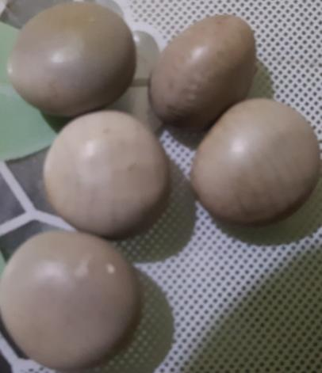
Fig.1. Caesalpinia bonducella L. Roxb. Seeds
Fig. 2. FTIR peak assignment of Caesalpinia bonducella seed extract.
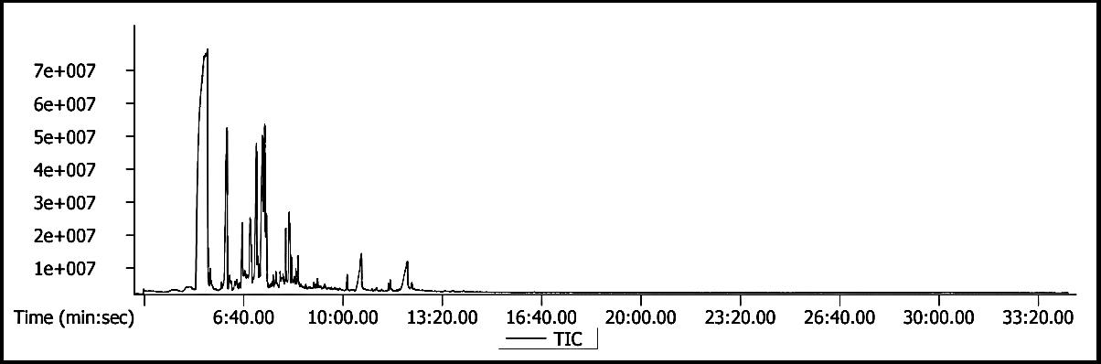
Fig. 3. Chromatogram of Gas chromatography mass spectrometry of Caesalpinia bonducella seed extract.
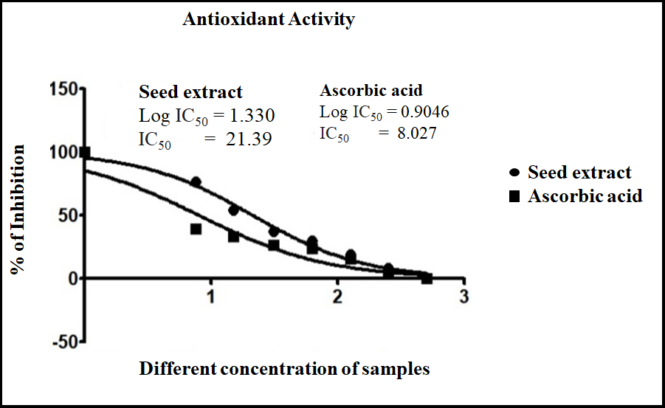
Fig. 4. % inhibition of free radical scavenging activity of Caesalpinia bonducella seed extract
.

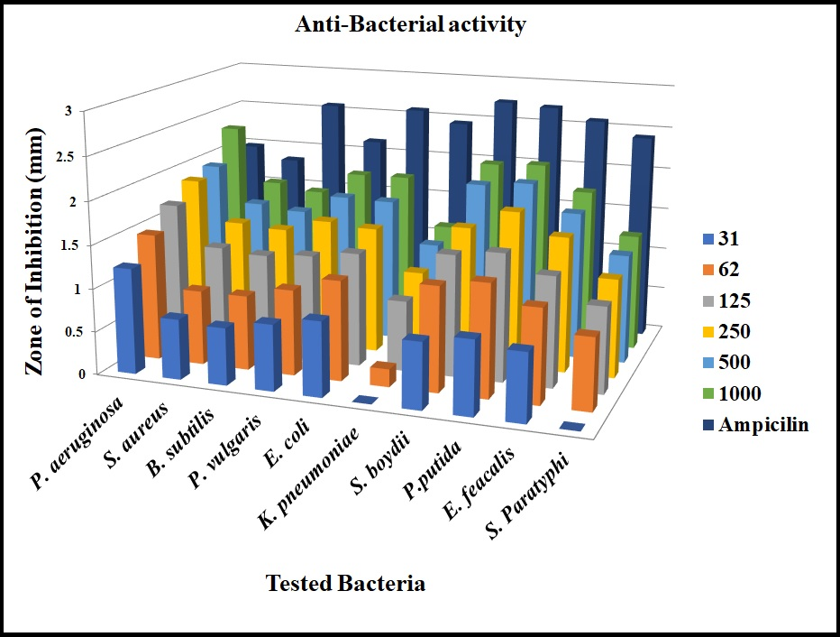
Fig. 5. Antibacterial activity of Caesalpinia bonducella seed extract.
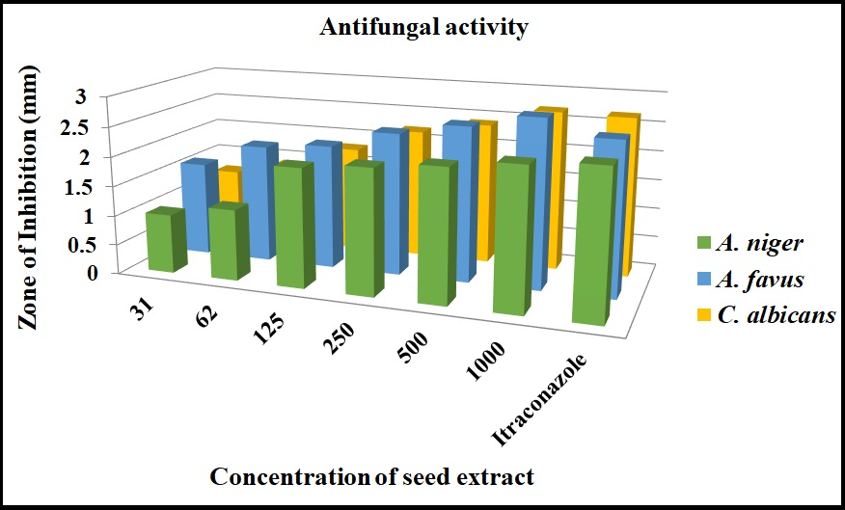Fig. 6. Antifungal activity of Caesalpiniabonducella seed extract
Table 1. Qualitative screening of phytochemicals of Caesalpinia bonducella seed extract
Phytocompounds | Water | Ethyl acetate | Ethanol | Methanol | Hexane | Chloroform
Phenols | + | - | - | + | + | -
Saponins | + | + | + | + | + | +
Anthroquiones | + | - | + | - | - | -
Lignins | - | + | + | + | + | -
Tepenoids | + | -- | + | + | - | -
Diterpenes | - | - | - | + | - | -
Flavonoids | - | + | + | + | - | +
Amino acids | - | - | + | + | - | -
Carbohydrates | + | - | + | + | + | +
Alkaloids | + | + | - | + | - | -
Glycosides | - | - | - | + | - | -
Phytosterols | - | + | + | + | - | +
Tannins | + | - | + | - | - | -
Quinone | + | - | - | + | - | -
(+) presence,(-) Absent.

Table 2. Functional group assessment from FTIR peak analysis of Caesalpinia bonducella seed extract
Sr. No. | Wave number or peaks of Methanol extract | Bond | Group frequency Cm⁻¹ | Functional group assignment
1 | 3325 | 0-H | 3570-3200 | Poly Hydroxy compound, phenols
2 | 2941 | 0-H | 2400-3500 | Lipids, protein
3 | 2845 | C-H | 2400-3500 | Carboxyilc acid
4 | 2077 | C≡C | 2300-1900 | Nitrile compound
5 | 1645 | N-H | 1650-1600 | Quinolines
6 | 1492 | C=C-C | 1510-1450 | Aromatic compound
7 | 1453 | C-H | 1340-1470 | Alkenes
8 | 1392 | O-H | 1410-1310 | Phenols, tertiary
9 | 1108 | C-O | 1140-1070 | Cyclic esters
10 | 1020 | C-O | 1100-1000 | Phosphate compound
11 | 572 | C-I | 600-500 | Aliphatic ido compounds

Table 3. List of bioactive compounds identified by Gas chromatography mass spectrometry in Caesalpinia bonducella seed extract
S. No | Name of the compound | Formula |  | RT | RI | RI from NIST | Area % | Area | Exact mass
1 | 2-Propen-1-ol, 3-phenyl- | C₉H₁₀O |  | 05:32.5 | 1259 | 1277 | 1.0806 | 118588610 | 134.0732
2 | Phenol, 2-methoxy-3-(2-propenyl)- | C₁₀H₁₂O₂ |  | 05:55.0 | 1297 | 1392 | 0.30885 | 33894834 | 164.0837
3 | .alfa.-Copaene | C15H24 |  | 06:06.1 | 1298 | 1221 | 17.954 | 1970308021 | 204.1878
4 | trans-à-Bergamotene | C15H24 |  | 06:31.6 | 1397 | 1433 | 0.34018 | 37332988 | 204.1878
5 | Naphthalene, 1,6-dimethyl-4-(1-methylethyl)- | C15H18 |  | 06:34.8 | 1423 | 1442 | 0.44115 | 48413850 | 198.1409
6 | 1,6-Cyclodecadiene, 1-methyl-5-methylene-8-(1-methylethyl)-, [S-(E,E)]- | C15H24 |  | 06:46.7 | 1454 | 1480 | 0.20357 | 22340395 | 204.1878
7 | à-Muurolene | C15H24 |  | 07:05.9 | 1468 | 1440 | 11.68 | 1281858512 | 204.1878
8 | trans-calamenene | C15H22 |  | 07:18.1 | 1487 | 1537 | 0.71221 | 78160337 | 202.1722
9 | Humulene | C15H24 |  | 07:24.1 | 1492 | 1454 | 0.77988 | 85587353 | 204.1878
10 | à-Calacorene | C₁₅H₂₀ |  | 07:26.4 | 1526 | 1529 | 0.832 | 91306812 | 200.1565
11 | Caryophyllenyl alcohol | C15H26O |  | 07:39.3 | 1560 | 1569 | 0.51535 | 56556316 | 222.1984
12 | Ledene oxide-(II) | C15H24O |  | 08:04.5 | 1602 | 1682 | 2.3789 | 261068390 | 220.1827
13 | Cubenol | C15H26O |  | 08:04.8 | 1618 | 1651 | 2.3789 | 261068390 | 222.1984
14 | à-Cadinol | C15H26O |  | 08:11.6 | 1626 | 1637 | 3.8448 | 421945571 | 222.1984
15 | 2-Propenoic acid, 3-(2-hydroxyphenyl)-, (E)- | C9H8O3 |  | 06:37.2 | 1638 | 1630 | 4.2611 | 467628194 | 164.0473
16 | à-Bisabolol | C15H26O |  | 08:28.9 | 1658 | 1653 | 1.1684 | 128228952 | 222.1984
17 | Pentadecanoic acid, 14-methyl-, methyl ester | C17H34O2 |  | 10:07.9 | 1802 | 1814 | 0.60684 | 66597114 | 270.2559
18 | n-Hexadecanoic acid | C16H32O2 |  | 10:36.7 | 1879 | 1942 | 5.7656 | 632734594 | 256.2402
19 | 7-Hexadecenoic acid, methyl ester, (Z)- | C17H32O2 |  | 11:35.1 | 1884 | 1886 | 0.66884 | 73400670 | 268.2402
RT- Retention Time, RI- Retention Index
Table 4. Biological activity of bioactive compounds identified by Gas chromatography mass spectrometry in Caesalpinia bonducella seed extract
S. No | Name of the compound | Biological activity
1 | 2-Propen-1-ol, 3-phenyl- | Antimicrobial activity, antioxidant activity
2 | Phenol, 2-methoxy-3-(2-propenyl)- | Anti-inflammatory, Hepatoprotective
3 | .alfa.-Copaene | Anti-genotoxic , Antioxidant
4 | trans-à-Bergamotene | Anti-microbial activity
5 | 2-Propenoic acid, 3-(2-hydroxyphenyl)-, (E)- | Anti-oxidant , anti-inflammatory
6 | 1,6-Cyclodecadiene, 1-methyl-5-methylene-8-(1-methylethyl)-, [S-(E,E)]- | Anti-microbial
7 | à-Muurolene | Antibacterial activity , antioxidant
8 | trans-calamenene | Anti-microbial , anti-oxidant
9 | Humulene | Anti-inflammatory , analgesic , anti-tumor
10 | à-Calacorene | Anti-microbial
11 | Caryophyllenyl alcohol | Anti-microbial
12 | Ledene oxide-(II) | Anti-bacterial, anti-microbial
13 | Cubenol | Anti-inflammatory , anti-microbial
14 | à-Cadinol | Anti-oxidant , anti-fungal
15 | Naphthalene, 1,6-dimethyl-4-(1-methylethyl)- | Anti-diabetic , anti-cancer, anti-oxidant
16 | à-Bisabolol | Anti-inflammatory , antibiotic
17 | Pentadecanoic acid, 14-methyl-, methyl ester | Anti-oxidant , anti-fungal
18 | n-Hexadecanoic acid | Anti-microbial , anti-inflammatory
19 | 7-Hexadecenoic acid, methyl ester, (Z)- | Anti-microbial , anti-inflammatory

