IN-VITRO PHYTOCHEMICAL AND ANTIOXIDANT ACTIVITIES OF CALLUS EXTRACT OF L. USITASSIMUM L.
Keerthi Priya Yadala ¹, Arifullah Mohammed ², Gaik Ee Lee ³, Khateef Riazunnisa ⁴, Gholamreza Abdi ⁵, Baber Ali ⁶, Muhammad Hamzah Saleem ⁷, Dan C. Vodnar ⁸, Romina Alina Marc ⁹, Awatif M.E Omran¹⁰, Azza Alareefy¹¹, Abdulrahman Alasmari¹² , Nisreen M. Abdulsalam¹³, Najla A. Khateeb¹⁴, Ayman El Sabagh ¹⁵
- Department of Biotechnology, Vignan`s Foundation for Science Technology and Research (Deemed to be University), Vadlamudi-522213, Guntur, Andhra Pradesh, India;
- Department of Agriculture Science, Faculty of Agro-Based Industry, Universiti Malaysia Kelantan, 17600 Jeli, Kelantan, Malaysia;
- Institute of Tropical Biodiversity and Sustainable Development, Universiti Malaysia Terengganu, 21030 Kuala Nerus, Terengganu, Malaysia;
- Department Biotechnology and Bioinformatics, Yogi Vemana University Kadapa, Andhra Pradesh 516005, India;
- Department of Biotechnology, Persian Gulf Research Institute, Persian Gulf University, Bushehr 75169, Iran;
- Department of Plant Sciences, Quaid-i-Azam University, Islamabad 45320, Pakistan; baberali@bs.qau.edu.pk
- College of Plant Science and Technology, Huazhong Agricultural University, Wuhan 430070, China;
- Institute of Life Sciences, Faculty of Food Science and Technology, University of Agricultural Sciences and Veterinary Medicine, 400372 Cluj-Napoca, Romania;
- Food Engineering Department, Faculty of Food Science and Technology, University of Agricultural Science and Veterinary Medicine Cluj-Napoca, 3-5 Calea Mănă ̧stur Street, 400372 Cluj-Napoca, Romania
- Department of Biochemistry, Faculty of science, University of Tabuk, Tabuk, Saudi Arabia;
- Jazan university, Clinical Nutrition Department, Applied Medical science collage, Saudi arabia;
- Affiliation: Department of Biology, faculty of Science, University of Tabuk, Tabuk Saudi Arabia;
- Department of Food and Nutrition, Faculty of Human Sciences and design, King Abdul Aziz University, P.O. Box 42807, Jeddah 21551, Saudi Arabia
- Clinical Nutrition Department, College of Applied Medical Sciences-King Saud bin Abdulaziz University for Health Sciences .
- Department of Agronomy, Faculty of Agriculture, Kafrelsheikh University, 33156 Kafrelsheikh, Egypt
*Correspondence: ayman.elsabagh@siirt.edu.tr
Abstract
In this study, callus induction protocol was standardized using different hormone concentrations with Modified Murashige and Skoog medium. The callus was well developed at the hormones concentration of 2,4-dichlorophenoxyacetic acid (0.8 mg/L)+6-benzylaminopurine (1 mg/L).On 30th day the callus culture was used for the experimental study, bioactive compounds like steroids, phytosterols, alkaloids, phenolics, flavonoids and tannins were screened. Total 14 bioactive compounds were identified in L. usitassimum L. extract by FTIR and GC-MS. Among them major compounds observed were n-hexadecanoic acid (12%), pentadecanoic acid ethyl ester (11%) and phytol (10%) followed by other compounds. The callus ethanol extract of L. usitassimum L. was tested against seven bacterial pathogenic organisms. The highest inhibition zone was found to be 21 mm against Shigella boydii. The maximum antioxidant activity (85%) was observed at 500 µg/mL concentration. Further, the callus extract showed better anti-proliferative activity against HepG2 cells 26.4 (μg/mL) and MCF-7 cells 45.1(μg/mL). Upon the results, the callus extract of L. usitassimum L. can be used functional ingredient in health and food applications.
Keywords: Antibacterial activity, Antioxidant activity, Phytochemicals, FTIR, GC-MS analysis, Biological Properties
1. Introduction
L. usitassimum L. is belonging to the family of Linaceae (Millam et al. 2005). It is a versatile, blue-flower herb of the USA, Western Argentina and Russia, cultivated in tropical regions all over the world (Deni1995). L. usitassimum L. is identified by its small and narrow leaves less than 25 mm. Flowers are mostly self-pollinated and rarely by cross-pollination by insects. L. usitassimum L. cultivated for obtaining a good amount of α-linolenic acid (ALA), linoleic acid (LA) and other unsaturated fatty acids for nutritional supplements (Kajla et al. 2015) and alsofor obtaining fiber and linseed oil purpose (You et al. 2019).
It is also used in the manufacture of paints and varnishes (Popovic et al. 2016). Linum can be used in drug synthesis, nutraceuticals, scaffolds and othertherapeutic applications (Shim et al. 2019).Flax gum (FG) extracted from L. usitassimum L. is locally called as Alsi, used as a stabilizer, thickener and moisture-retaining agent in food formulations (Rashid et al. 2019).Flaxseed helps in improving the function of endothelial cells (Kanikowska et al. 2019).
The flour taken from the seeds of linum is used in the preparation of burgers to increase nutrient content in the food (Cocaro et al. 2019).The L. usitassimum L. is having important medicinal compounds and these compounds are used to treat various human ailments such asabdominal pain, urinary infection, constipation, skin inflammation and upper respiratory infections (Basch et al. 2007).Hence the current study was focused on identification of phytochemicals from L. usitatissimum.L and evaluation of their in vitro biological activities.
2. Materials and methods
2.1. Source of chemicals
Chemicals-ethanol, ethyl acetate, methanol, chloroform, dimethyl sulfoxide, acetic anhydride, lead acetate, sulphuric acid, sodium hydroxide,ferric chloride, ammonium hydroxide, glycerol, agar, parafilm, tween-20, mercuric chloride,ascorbic acid, MS medium chemicals, indole-3-acetic acid, 2,4-dichlorophenoxyacetic acid, 6-denzylaminopurinefrom Himedia Chemicals, Hyderabad, India. Ampicillin, 2, 2-diphenyl-1-picrylhydrazylm, 3-(4, 5-dimethylthiazol-2-yl)-2,5-diphenyltetrazolium bromideand were procured from Sigma Chemicals, USA.
2.2. Collection of L. usitassimum L. seeds
The L.usitatissimum.L was collected from local market (Gudiwada Hanumanthu Rao Scientific Store, Tenali, Guntur, Andhra Pradesh, India). The collected seeds are carefully separated based on size and stored in airtight polythene bags to use them for the experimental purpose.
2.3. Microorganisms
The microorganisms such as Staphylococcus aureus (MTCC 6908), Pseudomonas aeruginosa (MTCC 10636), Bacillus subtilis (MTCC 1305), Pseudomonas vulgaris (MTCC 774), Escherichia coli (9537), Klebsiella pneumonia (MTCC 10309) and Shigella boydii (ATCC 9207) were procured from Culture Collection Centre (CSIR-Microbial Type Culture Collection, Chandigarh, India). Ampicillin (10 µg/mL) is used as a reference drug.
2.4. Surface sterilization
Known amounts of L. usitassimum L. seeds were taken and washed with running tap water about 10 min to remove dirt particles on the surface of seeds. Again the seeds were washed with tween-20 for about 3 min followed by sterile water till the foam was completely washed-out. The sterile seeds were brought to laminar airflow cabinet, treated with 0.1 % of mercury chloride for 3 min followed by sterile distilled water for about 1 min subsequently washed with 70% ethanol for 1 min, and repeatedly with sterile water and distilled water for 3 times to remove the trace elements. The seeds were sited on the modified MS medium and kept them in the dark conditions at 25 ºC for seed germination.
2.5. Initiation of callus from leaves of in vitro seedling of L. usitassimum L.
One week old leaves explants were used for the induction of callus culture. The explants were excised under sterilized conditions and placed on half strength modified MS medium containing various concentraitons of hormones: Indole-3-acetic acid (0.1-1.0 mg/L)+6-benzylaminopurine(0.5-5.0 mg/L), 2,4-dichlorophenoxyacetic acid(0.1-1.0 mg/L)+6-benzylaminopurine (0.5-5.0 mg/L) and 1-naphthaleneacetic acid (0.1-1.0 mg/L)+6-benzylaminopurine (0.5-5.0 mg/L).The cultures were preserved in the dark conditions for one week at 25 ºC. After one week, the cultures were exposed to photoperiod 16/8 h light/dark for 30 days. The 30th day old callus culture was extracted using different solvents and the prepared crude extracts for further experiments.
2.6. Preparation of callus extracts of L. usitassimum L.
About 25 g of callus culture was dried and crushed to powder. 15 g of callus powder was extracted with water, ethyl acetate, methanol and ethanol using Soxhlet apparatus (Chemico Glass & Scientific Company, India).The samples were dried using the rotary evaporator (Heidolph, Hei-VAP series, India) and then samples were stored in airtight bottles for further use. The stock solution (1 mg/mL concentration) was prepared and dissolved in DMSO and then used for anti-bacterial, anti-oxidant, and anti-proliferative activity studies.
2.7. Screening of phytochemicals in callus extracts of L. usitassimum L.
Different callusof L. usitatissimum.Lwere extracted for the screening of phytocompoundsphenolics, phytosterols, alkaloids, saponins, quinones, flavonoids and tanninsusing a standard protocol (Harborne 1973, Treaseand Evans 1983).
2.8. Callus extract of L. usitassimum L. by FTIR
Fourier transform infrared spectrophotometer (Cary 630 FTIR, Dimond ATR, Agilent technology, USA) is an excellent analytical instrument for the detection and characterization of functional groups of phytocompounds. 100 µL of the extract was loaded into the instrument. The compounds present in the extract have interacted with infrared light. The bonds present in the chemicals were stretched and contrasted. In this process at a specific wavelength, the functional group of the compound was absorbed the infrared radiation and the functional group of the phytocompound was identified. The spectra of chemical compounds were read at a range of 500-4000 cm⁻¹ in FTIR.
2.9. Callus extract of L. usitassimum L. by GC-MS
Phytocompounds were analyzed by GC-MS (model-7890A, Agilent Technologies, USA). It was furnished with a TOF-MS (LECO Corporation, USA). Separation of analytes was carried out by a capillary column (Agilent J and W HP-5 5 % Phenyl Methylpolysiloxane (0.32 mm ID, 30 m length, film thickness 0.25 μm). Ultra-high pure helium gas (99.99%) was carried with a flow rate of 1 mL/min. To calculate the retention indices, C₇ to C₄₀ n-alkane mixture (1 μg/μL) was run prior to the analysis of callus ethanol extract of L. usitassimum L. 1 μL of ethanol callus extract was manually injected into the inlet of the column at 250 ºC operating in a split less mode. Retention indices of each compound were calculated according to (Van den Dool 1974). The parameters, such as the retention time, similarity and retention index values were matched with that of peaks and subsequently identified through a NIST/EPA/NIH mass spectral library 2011 (Duke 1994).
2.10. Anti-bacterial activity of callus extract of L. usitassimum L.
The callus ethanol extract of L. usitassimum L. was carried out against the bacterial strains such as Staphylococcus aureus (MTCC 6908), Pseudomonas aeruginosa (MTCC 10636), Bacillus subtilis (MTCC 1305), Pseudomonas vulgaris (MTCC 774), Escherichia. Coli (9537), Klebsiella pneumonia (MTCC 10309) and Shigella boydii (ATCC 9207).These strains were maintained in 20 % glycerol stock and sub-cultured before use. The anti-bacterial activities were studied bythe agar well diffusion method (Yadala et al. 2017; Perez 1990; RangaRao et al. 2010). A known amount of agar medium (20 mL) was transferred into sterilized Petri plates and allowed to solidify. The bacterial strains were spread on petriplates using L-shaped rod. Wells (5mm diameter) were made in the agar medium by sterile cork borer. Callus ethanol extracts (1 mg/ mL) as sample, DMSO as control, and ampicillin (20 µg/mL) as standard were used and then filled on the agar plate wells. Agar plates wrapped with parafilm and kept them in 37⁰C for 1-2 days. Inhibition zone was measured (mm) after the incubation time. The experiment was repeated thrice and Mean ± SD of the readings were calculated.
2.11. Anti-oxidant activity of callus extract of L. usitassimum L. by DPPH
The antioxidant activity of callus extract was evaluated by DPPH method (Yadala and Asha, 2018).The DPPH method has been widely accepted tool for estimating antioxidants present in the extracts. Different concentrations of callus extract was taken (15, 30, 60, 125, 250 and 500 µg/mL) and mixed with 3 mL of prepared DPPH solution. The mixtures were vigorously shacked and incubated in dark at RT for about 30 min. After the incubation time, sample was read at 517 nm using UV-Vis spectrophotometer and the ascorbic acid used as standard. The experiment was repeated in three times and the percentage (%) of activity was calculated by the formula: ((A⁰-A¹)/A⁰) ×100.A⁰ indicates absorbance of control and A¹ indicates the absorbance of sample.
2.12. Anti-proliferative effects of callus extract of L. usitassimum L.
The viability of HepG2 and MCF-7 cells was tested by MTT (MA, USA) assay with callus extract in triplicates (Szewczyk et al. 2014). The viability of cells was done by trypsinizing the cells by trypan blue assay in the cell suspension followed by cell counting using a hemocytometer and spread at a density of 5 x 10³ cells /well. 100 μL of DMEM was dispersed into 96 well plates and incubation at 37⁰C for over night. The old medium was removed by adding 100 µL fresh medium containing callus extracts to 96 well plates. The drug solution was removed by adding a fresh medium of MTT (0.5 mg/mL) to 96 well plates. The samples were incubated in 37 ⁰C for 3h. Metabolically active mitochondria in the cells reduced MTT salt to form crystals of chromophoreformazan. The dissolved crystals were measured at 570 nm using microplate reader. The percentage of inhibition was computed by the formula: (Control –Sample) x 100/Control.
2.13. Statistical Analysis
The data of anti-bacterial, anti-oxidant and anti-proliferative effects are the averages of mean of three independent experiments with standard deviation (SD). The data was analyzed by ANOVA using MS-Excel (Microsoft Corp. Redmond, WA). The value p<0.05 is showed statistically significant for analysis of experimental data.
3. Results and discussion
3.1. Raising of aseptic seedlings and initiation of callus from leaf explants L. usitassimum L.
Under aseptic conditions, the sterilized seeds were transferred to the MS medium. It was observed that the seeds started germination on the 3rdday of inoculation. The leaves from 7th day seedlings L. usitassimum L. were placed on half strength modified MS medium containing various concentrations of hormones such as Indole-3-acetic acid (0.1-1.0 mg/L)+6-benzylaminopurine (0.5-5.0 mg/L), 2,4-dichlorophenoxyacetic acid (0.1-1.0 mg/L)+6-benzylaminopurine (0.5-5.0 mg/L) and 1-naphthaleneacetic acid (0.1-1 mg/L)+6-benzylaminopurine (0.5-5.0 mg/L). The induction of callus from leaf explants was observed on 5th day of inoculation. The callus culture was tested in all the concentrations of hormones. Among the tested concentrations, the best callus culture in terms of light creamy, greenish colored and friable was found in the tested concentration of 2,4-dichlorophenoxyacetic acid (0.8 mg/L)+6-benzylaminopurine (1.0 mg/L) as shown in Fig. 1A-1D.
3.2. Phytochemical analysis of callus leaf extract of L. usitassimum L.
The callus obtained from leaf of L. usitassimum L. was extracted using various solvents for screening of phytochemical compounds. The results observed that the ethanol extract contains presence of more phenols, phytosterols, saponins alkaloids, flavonoids and tannins followed by methanol, ethyl acetate and water extracts (Table 1). Further, in vitro biological properties like anti-oxidant, anti-bacterial and anti-proliferative effect of callus ethanol extract were tested.
3.3. FTIR analysis of callus extract of L. usitassimum L.
The elucidation of structural and functional groups of the chemical constituents in L. usitassimum L. callus extract was identified by FTIR. Upon the load of sample on the FTIR, the functional groups of phytochemical compounds were identified based on the peak values range in infrared radiation. Based on the FTIR results, polyhydroxy, lipids, proteins, carboxylic acid, nitrile, aldehyde, quinolines, alkenes, phenols, tertiary cyclic esters, phosphate, aliphatic chloro, aliphatic bromoand aliphatic iodo compounds in ethanol extract were detected (Fig 2 & Table 2).
3.4. GC-MS analysis of callus extract of L. usitassimum L.
In GC-MS analysis, fourteen compounds were identified by using NIST-11 library based on retention time, retention index compared with library values shown in Table 3. The identified bioactive compounds were octanoic acid, n-decanoic acid, 2,6-bis(1,1-dimethylethyl), phenol, 2(4h) - benzofuranone, diethyl phthalate, dodecanoic acid, 5,6,7,7a-tetrahydro-4,4,7a-trimethyl, pentadecanoic acid, 3,7,11,15-tetramethyl-2-hexadecen-1-ol, phytol, ethyl ester, α-linolenic, n-hexadecanoicacid, trimethylsilyl ester, 2,3-bis (acetyloxy)propyl ester (Z,Z,Z), 9,12,15-octadecatrienoic acid, hexadecanamide, 3-eicosene, (E). The similar bioactive compounds were reported in various extracts of Bryophyllum pinnatum (Adibe et al. 2019), Gracilaria corticata (Ragunathan et al. 2019); Tylopora pauciflora (Starlin et al. 2019) Alstonia scholaris (Swamy et al. 2019), Streptomyces parvulus (Baskaran et al. 2016), Sterculiaurens Roxb (Nanadagopalan et al.2015), Wrightia tinctoria (Rajendra et al. 2015) and the details of bioactive compounds were shown in Table 4.
3.5. Anti-bacterial activity of callus extract of L. usitassimum L.
Anti-bacterial activity of callus ethanol extract was studied against pathogenic bacteria with the standard drug ampicillin. The results revealed that the ethanol callus extract was shown activity against seven bacterial strains P. aeruginosa(10636), S. aureus(6908),B. subtilis(1305),P. vulgaris (744), E. coli (9537), K. pneumonia(10309),and S. boydii (ATCC 9207).Among all the organisms tested bacteria strains, S. boydii showed highest inhibition (21.5 mm) zone (Fig. 3A). Mendhulkar and Sakhare (2017) reported the ethanol callus extract of L. usitassimum L. showed most effect on klebsiella pnemoniae with the zone of inhibition 13.3 mm.The similar findings were observed for in vitro anti-bacterial activity of extracts of Alstonia scholaris (L.), Wrightia tinctoria and algae against bacterial strains (Yadala et al. 2017; Yadala and Asha, 2018; Swamy et al. 2019; Ranga Rao et al. 2010).
3.6. Anti-oxidant activity of callus extract of L. usitassimum L.
Various concentrations of callus extract were tested for antioxidant activity. Among the tested concentrations, the maximum antioxidant activity 85.62% was observed in 500 µg/mL concentration (Fig. 3B).This potential activity is due to presence of phenolics, fatty acids, terpenoids and alkaloids in the sample. These results reveal callus extract was a good source of antioxidants and it supports the therapeutic use of this plant. Similar observations were found when the callus leaf extract of L. usitassimum L. was tested for antioxidant activities by Anjum et al (2017). Yadala and Asha (2018) reported that chloroform crude callus extracts of Wrightia tinctoria showed better antioxidant activity. The leaf extract of Bryophyllumpinnatum was tested for antioxidant activity (Adibe et al. 2019)
3.7. Anti-proliferative activity of callus extract of L. usitassimum L.
The anti-proliferative activity of callus ethanol extract of L. usitassimum L. was tested on HepG2 and MCF-7 cells using MTT assay. The cell growth and the viability of cells were declined upon the dose of callus extract. The 50% inhibition concentration againstMCF-7, HepG-2 and Cisplatin cells were found to be 45.1(μg/mL), 26.4 (μg/mL) and 3.09 (μg/mL) respectively. It was found that the anti-proliferative activity was more effective in HepG2 when compared to the MCF-7 (Fig 4). Previously, the root extract of L. usitatissimum.L showed cytotoxic effect against MCF-7 cells, reported by Szewczy et al. (2014).
4. Conclusions
In this study, the callus induction protocol was standardized using different hormone concentrations with half strength MS modified medium. The best concentration of hormones: 2, 4-dichlorophenoxyacetic acid (0.8 mg/L) + 6-benzylaminopurine (1 mg/L) was observed. The phytochemicals like phenolics, phytosterols, alkaloids, steroids, tannins and flavonoids were screened using standard protocols. Fourteen bioactive compounds were identified by FTIR, GC-MS analysis and their anti-bacterial, anti-oxidant and anti-proliferative effects using in-vitro models were studied. The callus ethanol extracts of L. usitatissimum L. was tested against seven pathogenic organisms. The highest inhibition was found in S. boydii. The ethanol extract showed a better antioxidant activity in DPPH method and anti-proliferative activity on HepG2 and MCF-7. Upon the current observations, the phytochemicals from callus ethanol extract of L. usitatissimum L. could be used in the development of novel bio-molecules for health applications.
Author’s contribution:
Conceptualization, Yadala Priya; Formal analysis, Riazunnisa Khateef; Funding acquisition, Baber Ali, Muhammad Saleem, Dan Vodnar and Romina Alina Marc; Investigation, Yadala Priya; Methodology, Yadala Priya; Project administration, Romina Alina Marc; Resources, Muhammad Saleem and Romina Alina Marc; Software, Gaik Ee Lee, Riazunnisa Khateef, Baber Ali and Dan Vodnar; Supervision, Arifullah Mohammed; Validation, Arifullah Mohammed and Romina Alina Marc; Visualization, Gaik Ee Lee; Writing – original draft, Gholamreza Abdi and Baber Ali; Writing – review & editing, Arifullah Mohammed, Gaik Ee Lee, Riazunnisa Khateef, Gholamreza Abdi, Baber Ali, Muhammad Saleem, Dan Vodnar and Romina Alina Marc.
Funding: The publication was supported by funds from the National Research Development Projects to finance excellence (PFE)-14/2022-2024 granted by the Romanian Ministry of Research and Innovation.
Institutional Review Board Statement: Not applicable.
Informed Consent Statement: Not applicable
Conflict of interest: Authors declare no conflict of interest
5. References
- Adibe MK, Gabriel IM, Akintunde AAM, Esther AO (2019) Chemical compositions and antioxidant activity of leaf and stem essential oils of Bryophyllumpinnatum(lam.) Kurz. GSC Biol PharmSci9(2):057-064
- Anjum S, Abbasi BH, Hano C (2017) Trends in accumulation of pharmacologically important antioxidant-secondary metabolites in callus cultures of Linumusitatissimum L.Plant Cell Tiss Org 129(1):73-87
- Basch E, Mphil SB, Collins J, Dacey C, Harrison M, Szapary P (2007) Flax and flaxseed oil (L. Usitatissimum.L): a review by the natural standard research collaboration. J Soc Integr Oncol,5(3):92-105
- Baskaran R, Mohan PM, Sivakumar K, Kumar A (2016) Antimicrobial activity and phylogenetic analysis of Streptomyces parvulus dosmb-D105 isolated from the mangrove sediments of Andaman Islands. ActaMicrobiol Immunol Hung63(1):27-46
- Cha BC, Lee SB (2000) Synthesis and biological activity of asprin derivatives. Arch Pharm Res 23(2):116-120
- Cocaro ES, Laurindo LF, Alcantara M, Martins IBA, Junior AAB, Deliza R (2019) The addition of golden flaxseed flour (L. Usitatissimum.L.) in chicken burger: Effects on technological, sensory, and nutritional aspects. Food Sci Technol Int26(2):105-112.
- Deni, B. (1995). Encyclopedia of herbs and their uses. Dorling Kindersley, the University of Michigan, Page no:424
- Duke J, Bogenschutz MJ (1994) Dr. Duke's phytochemical and ethnobotanical databases, USDA, Agricultural Research Service pp:1-8
- Harborne JB (1973) Textbook of phytochemical methods, 1st Edn, Champraan and Hall Ltd. London, pp. 110-113
- Kanikowska D, Rutkowski R, Pawlaczyk K, Sato M, Misian M, Bręborowicz A, Witowski, J (2019) The effectiveness of flaxseed (L. Usitatissimum.L.) on the inflammatory response in patients with familial hypercholesterolemia receiving lipid apheresis-preliminary results. The FASEB J3(1):755.2-755.2
- Kajla P, Sharma A, Sood DR (2015) Flaxseed a potential functional food source. J Food Sci Technol 52(4):1857-1871
- Mendhulkar VD, Sakhare SP (2017) Antimicrobial activity of the seed and callus biomass extract of linumusitatissimumL. against some strains of clinically important pathogens. Int J Pharm Bio Sci8(4):263-268
- Millam S, Obert B, Pretova A (2005) Plant cell and biotechnology studies in L. Usitatissimum.L-a review. Plant Cell Tiss Org Cult 82(1):93-103
- NanadagopalanV, Johnson Gritto M, Doss A (2015) GC-MS analysis of biomolecules on the leaves extract of SterculiaurensRoxb. JPharm Phytochem3(6):193-196
- Perez C, Pauli M, Bazerque P (1990) An antibiotic assay by agar well diffusion method. Acta Biologiae et MedicinaeExperimentalis. 15:113-115
- Phukan H, Bora CR, Mitra PK(2017) Phytochemical screening and GC-MS analysis of methanolic leaf extract of an endemic plant kayeaassamica. IOSR J Pharm Biol Sci 12(5):7-16
- Popovic V, Sikora V, Tatic M, Filipovic V, Terzic D, Janjic S, Jokanovic, MB (2016) Analysis of production of linseed (LinumUsitatissimum L.) in the World. 20thInternational Eco-Conference and 9th International Eco-Conference on Safe Food, pp:119-127
- Ragunathan V, Pandurangan J, Ramakrishnan T (2019) Gas chromatography-mass spectrometry analysis of methanol extracts from marine red seaweed gracilariacorticata. PharmacognJ11(3):547-554
- Rajendra S, Arun K, Vinod KM (2015) Phytochemical analysis of Wrightiatinctoria bark extract in water using GC-MS. Int J Surg 7(3):470-472
- Ranga Rao A, Harshavardhan Reddy A, Aradhya SM (2010) Antibacterial properties of Spirulinaplatensis, Haematococcuspluvialis, Botryococcusbraunii micro algal extracts. Curr Trends BiotechnolPharm4(3):809-819
- Rashid F, Ahmed Z, Hussain S, Huang JY, Ahmad A (2019) L. Usitatissimum.L. Seeds: Flax gum extraction, physicochemical and functional characterization. CarbohydrPolym215:29-38.
- Shim YY, Song Z, Jadhav PD, Reaney MJ (2019) Orbitides from flaxseed (L. Usitatissimum.L.): A comprehensive review. Trends Food Sci Technol 93: 197-211
- Starlin T, Prabha PS, Thayakumar BKA, Gopalakrishnan VK (2019) Screening and GC-MS profiling of ethanolic extract of Tylophorapauciflora. Bioinformation, 15(6): 425-429
- Swamy NT, Rosaiah G, Babu K, Kumar KV (2019) A Study on phytochemical composition, GC-MS analysis and anti-microbial potential of methanolic leaf extract of AlstoniaScholaris (L.) R. BR. Int J Pharm Sci Res 10(3): 747-55.
- Szewczyk M, Abarzua S, Schlichting A, Nebe B, Piechulla B, Briese V, Richter DU (2014) Effects of extracts from Linumusitatissimumon cell vitality, proliferation and cytotoxicity in human breast cancer cell lines. J Med Plants Res8(5): 237-245.
- Trease GE, Evans IC (1983) Pharmacognosy (12thedn) BailliereTindall London, pp.21-22.
- Van den Dool H (1974) Standardization of GC analysis of essential oils. Proefschrift, Rijksuniversiteitte Groningen, Rotterdam.
- Yadala KP, Asha S (2018) Characterization and evaluation of antibacterial, antioxidant and cytotoxicity of synthesized silver nanoparticles (AgNps) using chloroform crude callus extracts of Wrightiatinctoria (Roxb.). CurrTrends Biotechnol Pharm 12(3):275-285
- Yadala KP, Gopenath TS, Kumar RB, Asha S (2017) Antimicrobial activity studies on seed fibers of Wrightiatinctoria (Roxb.) R. Br. Res J Pharm Biol Chem Sci 8(1):795-802
- You FM, Cloutier S, Rashid KY, Duguid SD (2019) Flax (L. Usitatissimum.L.) genomics and breeding. In: Al-Khayri, Jameel M, JainSM, Johnson, Dennis V (eds) Advances in plant breeding strategies: Industrial and food crops. Springer, Cham, pp.277-317

Table 1. Screening of phytochemicals from callus extracts of L. usitatissimum L.
Phytochemical | Water | Ethyl acetate | Methanol | Ethanol
Phenols | + | + | + | +
Phytosterols | - | + | + | +
Saponins | - | - | - | -
Alkaloids | + | + | + | +
Flavonoids | - | - | - | +
Tannins | + | + | + | +
Triterpenoids | + | + | + | +
Glycosides | - | - | + | +

Table 2. Peak values of callus extract of L. usitatissimum L. by FTIR
S. No | Wavelength  (Cm⁻¹) | Bond | Group frequency (Cm⁻¹) | Functional group
1 | 3433 | O-H | 3570-3200 | Poly hydroxy compound, phenols
2 | 3000 | O-H | 2400-3500 | Lipids, protein
3 | 2923 | C-H | 2400-3500 | Carboxylic acid
4 | 2108 | C≡C | 2300-1900 | Nitrile compound
5 | 1721 | C=O | 1740-1720 | Aldehyde compound
6 | 1633 | N-H | 1650-1600 | Quinolines
7 | 1424 | C-H | 1340-1470 | Alkenes
8 | 1355 | O-H | 1410-1310 | Phenols, tertiary
9 | 1142 | C-O | 1140-1070 | Cyclic esters
10 | 783 | C-H | 800-700 | Aliphatic chloro compounds
11 | 532 | C-I | 600-500 | Aliphatic iodo compounds

Table 3. Identification of bioactive compounds in callus extract of L. usitatissimum L. by GC-MS.
S. No | Compound Name | Formula | Relative  (%) | Mass
1 | Octanoic acid | C₈H₁₆O₂ | 1.04 | 144.11
2 | n-Decanoic acid | C₁₀H₂₀O₂ | 2.06 | 172.14
3 | Phenol, 2,6-bis(1,1-dimethylethyl)- | C₁₄H₂₂O | 2.14 | 206.16
4 | 2(4H)-Benzofuranone, 5,6,7,7a-tetrahydro-4,4,7a-trimethyl- | C₁₁H₁₆O₂ | 1.02 | 180.11
5 | Diethyl Phthalate | C₁₂H₁₄O₄ | 5.01 | 222.08
6 | Dodecanoic acid | C₁₂H₂₄O₂ | 7.18 | 200.17
7 | 3,7,11,15-Tetramethyl-2-hexadecen-1-ol | C₂₀H₄₀O | 4.03 | 296.30
8 | Pentadecanoic acid, ethyl ester | C₁₇H₃₄O₂ | 11.54 | 270.25
9 | n-Hexadecanoic acid | C₁₆H₃₂O₂ | 12.69 | 256.24
10 | Phytol | C₂₀H₄₀O | 10.05 | 296.30
11 | α-Linolenic acid, trimethylsilyl ester | C₂₁H₃₈O₂Si | 1.05 | 350.26
12 | 9,12,15-Octadecatrienoic acid, 2,3-bis(acetyloxy)propyl ester (Z,Z,Z) | C₂₅H₄₀O₆ | 1.09 | 436.28
13 | Hexadecanamide | C₁₆H₃₃NO | 2.11 | 255.25
14 | 3-Eicosene (E) | C₂₀H₄₀ | 1.46 | 280.31

Table 4. Reported biological activities of phytochemicals in callus extract of L. usitatissimum L.

S. No | Compound Name | Biological properties | Phytochemical  Compounds | Reference
1 | Octanoic acid | Anti-candidal activity, anti-bacterial activity | Fatty acid | Cha and Lee 2000;  Ragunathan et al. 2019
2 | n-Decanoic acid | Anti-tumor, inhibit the production of tumor necrosis factor, anaphylactic activity | Fatty acid | Duke 1994
3 | Phenol, 2,4-bis (1,1-dimethylethyl)- | Anti-microbial, anti-oxidant, anti-inflammatory, analgesic | Alkylated phenol | Baskaran et al. 2016
4 | n-Hexadecanoic acid | Anti-oxidant, hypocholesterolemic, hemolytic, pesticide | Fatty acid | Rajendra et al. 2015
5 | Phytol | Anti-nociceptive, anti-oxidant, anti-cancer, anti-inﬂammatory, anti-microbial, diuretic, chemopreventive properties | Diterpene alcohol | Nanadagopalan et al. 2015
6 | 3-Eicosene, (E)- | Anti-cancer activity | Un saturated fatty acid | Duke 1994; Adibe et al. 2019
7 | 3,7,11,15-Tetramethyl-2-hexadecen-1-ol | Anti-cancer activity | -- | Duke 1994; Starlin et al. 2019
9 | 2(4H)-Benzofuranone, 5,6,7,7a-tetrahydro-4,4,7a-trimethyl- | Histamine inhibitor, HIV-RT-inhibitor, hyperglycemic, increase T-helper, ACE inhibitor, analgesic, anti-arthritic, antacid, anti-biotic, anti-cancer, anti-coagulant, anti-diuretic, anti-microbial, anti-oxidant, | Triterpenoid | Swamy et al. 2019
10 | 9,12-Octadecadienoic acid, methyl ester, (E, E) | Anti-inflammatory, anti-androgenic, anti-histaminic, anti-eczemic, anti-acne, anti-coronary | Unsaturated fatty acid | Duke 1994
11 | α-Linolenic acid, trimethylsilyl ester | Arachidonic acid inhibitor, inhibit production of uric acid | Un saturated fatty acid | Duke 1994,  Phukan et al. 2017

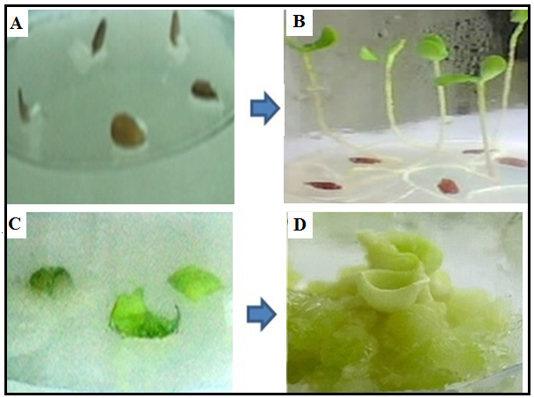
Fig. 1. (A) Seed germination of L. usitassimum L., (B) 7th day seedling of L. usitassimum L., (C) Inoculated leaf explants on the modified MS medium, and (D) Callus initiation 2, 4 dichlorophenoxyacetic acid (0.8mg/L) + 6-benzylaminopurine (1mg/L).

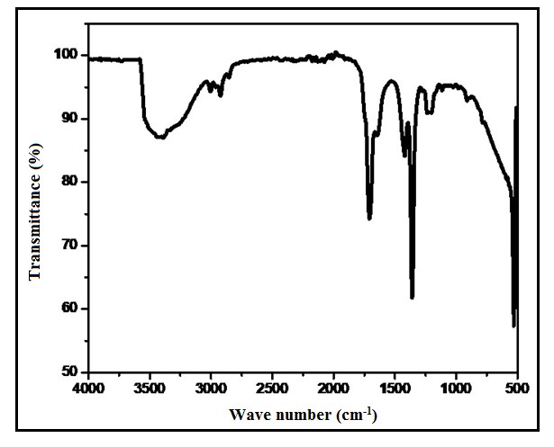
Fig 2. FTIR peak values of callus ethanol extract of L. usitassimum L.

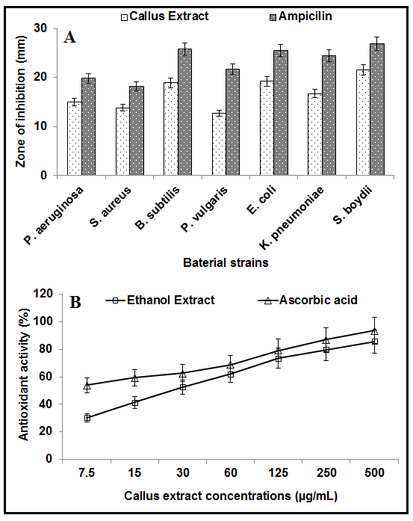
Fig 3. Antibacterial (A), and antioxidant (B) activity of callus ethanol extracts of L. usitassimum L.

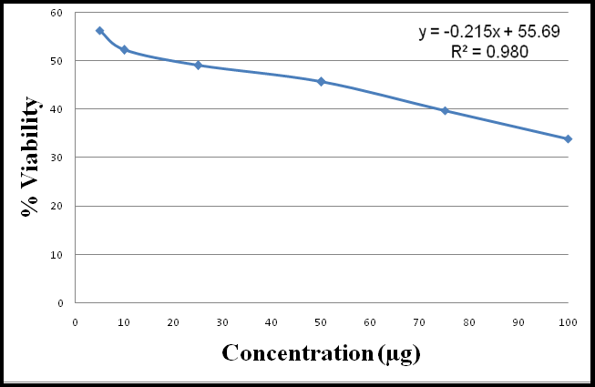
Fig 4. Anti-Proliferative activity of callus ethanol extracts of L. usitassimum L.

